Understanding research on risk and protective factors for intimate partner violence
Pauline Gulliver,¹ PhD & Janet Fanslow,² PhD
¹ Research Fellow, School of Population Health, University of Auckland
² Associate Professor, Social and Community Health, School of Population Health, University of Auckland;
Co-Director, New Zealand Family Violence Clearinghouse
Key Messages
- Conceptual models guide the exploration of risk and protective factors.
  - Conceptual models help us to organise our thoughts and identify relationships between the different risk and protective factors for intimate partner violence, and other forms of violence.
  - Some conceptual models (such as the ecological model) have helped to expand our understanding of the wider societal and community factors that impact on violence experience.
  - Consistent findings at the international level have allowed the identification of a common set of factors that are strongly associated with violence experience, but these are not the only factors that influence the likelihood of violence occurring.
- There are some challenges involved with measuring some risk or protective factors
  - Most of the research identifying risk and protective factors for intimate partner violence collect information at only one point in time. The result is that it is difficult to establish whether factors that are related to violence experience caused the violence or are a result of experiencing the violence (or both).
  - While, the use of controlling behaviours is strongly associated with violence experience, behaviours can mean different things to different people. It is important to understand the context of an abuser’s behaviour in order to fully understanding the meaning.
- There is no “one true cause” of intimate partner violence.
  - Violence is typically the outcome of the interaction of many different factors.
  - Individual, relationship, community, social and cultural factors work together to enhance or reduce the likelihood of violence being perpetrated or experienced.
  - Violence is a behaviour which is governed by choice. Decisions and subsequent actions are influenced by societal attitudes about what is considered acceptable behaviour.
- A comprehensive, multi-pronged approach is required to address intimate partner violence as well as other forms of family violence in New Zealand.
  - Lessons can be learned from systematic approaches to addressing other problem behaviour patterns. For example, addressing the road toll required:
    - Investment in infrastructure
    - Legislation to reduce risk
    - Social marketing campaigns
    - Improvements in safety design
    - Swift and sure punishment where laws were broken
    - Increased resourcing at high risk periods
    - Consistent and adequate funding over a sustained period of time
- To optimise the likelihood of success a long-term investment in policy, infrastructure and communities is required. This needs to be supported by an overall strategic government framework for addressing IPV.

The New Zealand Family Violence Clearinghouse can be contacted at:
New Zealand Family Violence Clearinghouse
Tāmaki Campus
University of Auckland
Private Bag 92019, Victoria Street West
Auckland 1142
New Zealand
Phone: + 64 9 923 4640
Email: info@nzfvc.org.nz
Website: www.nzfvc.org.nz
ISSN: 2253-3222 (online)
Recommended citation
Gulliver, P., and Fanslow, J. (2016). Understanding research on risk and protective factors for intimate partner violence. Auckland, New Zealand: New Zealand Family Violence Clearinghouse, University of Auckland.
Acknowledgements
Thank you to Jane Koziol-McLain (Professor of Nursing, Centre for Interdisciplinary Trauma Research, AUT) and Sheryl Hann (NZFVC Sector Advisory Group member) for their feedback on earlier versions of this paper.

Glossary
Term | Definition
Correlation | A measure of association between two factors
Causation | A factor that makes a difference in the outcome (or the probability of the outcome) when it is present, compared with when it is absent, while all else is held constant¹
Epidemiology | The study of the distribution and determinants of health-related states or events in specified populations, and the application of this study to the control of health problems (Last 2001, p.61)²
Representative | A group of people who share the characteristics of the population who they are chosen to represent, generally with respect to the distribution of age, gender, ethnicity and socio-demographic (income level, employment) characteristics³
Ecological investigations | Disease rates and exposures to risk or protective factors are measured in a series of populations and their relationships are examined³
Cross-sectional studies | Measures the rates of a health outcome and the risk and/or protective factors for a health outcome within a population at a single point in time³
Cohort studies | A group of people are followed over time with regular measurement of risk and protective factors and health outcomes³
Rate | The relative frequency with which an event occurs among a defined population per unit of time⁴
Protective factor | An aspect of personal behavior or lifestyle, an environmental exposure, or a hereditary characteristic that is associated with a decrease in the occurrence of a particular disease, injury, or other health condition⁴
Risk factor | An aspect of personal behavior or lifestyle, an environmental exposure, or a hereditary characteristic that is associated with an increase in the occurrence of a particular disease, injury, or other health condition⁴

Introduction
Intimate partner violence (IPV), as with other forms of family violence, has been termed a “complex problem” (p.559).⁵ This means that the likelihood of experiencing or perpetrating IPV is related to a complex interplay of a number of different variables. While this complexity is often acknowledged on paper, there can be a tendency to oversimplify, and to attribute causal explanations related to the perpetration of violence to a sole factor, or limited interplay of factors. For example, single factor explanations commonly suggested include alcohol use,⁶ or individual characteristics such as poverty.⁷ In contrast, this paper highlights that it is typically a constellation of risk factors that combine to result in someone experiencing or perpetrating IPV.
Two things govern researchers’ ability to explore and understand risk and protective factors related to IPV: (1) the conceptual models of what factors we think might influence the outcome, and (2) our ability to measure these factors and establish a relationship with IPV experience.
The aims of this paper are to:
- Present some of the conceptual models that have guided exploration of risk and protective factors,
- Provide an understanding of the characteristics of the research that has led to the identification of the factors related to IPV experience,
- Highlight the challenges involved with the measurement of risk and protective factors for IPV,
- Counter misconception that there may be any one true cause of IPV, and
- Underscore the need for a comprehensive, multi-pronged strategy to addressing IPV within New Zealand.
Intimate partner violence, along with other forms of violence, is not only a health issue, but is also a human rights, social, economic and a justice issue. However, this paper is largely set within the health paradigm as the majority of published research that describes the risk and protective factors for intimate partner violence has also come from this paradigm. It primarily looks at quantitative health research.
We have chosen to focus on IPV because, at the time of writing, the majority of research for understanding risk and protective factors that can potentially modify the prevalence of family violence experience has focused on IPV, primarily men’s violence against woman partners. However, while specific factors may vary, the key concepts contained within this paper also apply to child maltreatment, elder abuse and other forms of family violence.
The field of IPV research is relatively young,⁹ with its roots in feminist activism which gained traction during the United Nations Decade for women (1975-1985¹⁰). Significant early steps made by women’s groups identified violence against women as a human rights abuse and “a major obstacle to achieving the objectives of the Decade for Women: equality, development and peace” ¹⁰ (p.14). The finding that the majority of violence experienced by women was perpetrated by a current or former intimate partner¹¹ established the importance of addressing IPV as a priority within the wider issue of gender based violence.
Within this issues paper we have not provided a detailed review of all known risk or protective factors for IPV. A number of such papers exist, and a selection of these is provided in the Appendix. Instead, we have provided an overview of some of the conceptual models from which risk and protective factors are drawn, and outlined the types of studies that are frequently employed for the identification of such factors. Our purpose is to provide the reader with an understanding of the complexities involved with identifying risk and protective factors.

Understanding IPV research (conceptual models)
To begin, we provide an overview of the conceptual models from which risk and protective factors for IPV are drawn. Conceptual models are important as they provide “a framework within which social phenomena can be understood and the research findings interpreted” (p.20).¹³ Conceptual models are the pictures that come into our minds when we think of IPV or other forms of violence. Where we understand IPV as being related to a number of different risk and protective factors, conceptual models help us to organise our thoughts and form relationships between these factors. The conceptual model(s) researchers and practitioners use influences what is explored by way of risk and protective factors. Much like shining a torch in a dark cave, we only see what we chose to shine the light on.
To understand the risk and protective factors that influence IPV experience, a number of different research approaches are used, which are characterised through different fields of epidemiology. Pool and Rothman (1998) describe four visions of epidemiology:
- Social epidemiology – seeking to understand the social determinants of health events,
- Risk factor epidemiology – identifying behaviours and exposures related to health events,
- Molecular epidemiology – identifying the biological mechanisms that relate to the experience of health events.
- Eco-epidemiology – understanding the interconnection of societal (social), lifestyle (risk factor) and molecular explanations of health events.¹⁴
IPV research sits within eco-epidemiology, specifically focusing on the societal and lifestyle factors of those who perpetrate and experience violence in order to identify which factors are associated with an increased or reduced likelihood of IPV occurring. An example of the conceptual framework which guides this work is the ecological framework followed by the Violence Prevention Alliance at the World Health Organisation (Figure 1). The ecological model, as considered by the Violence Prevention Alliance, represents risk and protective factors for interpersonal violence experience as being divided into four levels: the societal (national), community (local), relationship (including the characteristics that individual partners bring to the relationship), and the individual level. The ecological model allows us to broaden our conceptualisation of factors that relate to violence experience, highlighting that “no single factor can explain why some people or groups are at higher risk of interpersonal violence ... interpersonal violence [is] the outcome of interaction among many factors.”¹⁵ The ecological model is presented as nested ovals to encourage people to acknowledge the interplay of factors within and across the individual levels.
“no single factor can explain why some people or groups are at higher risk of interpersonal violence ... interpersonal violence [is] the outcome of interaction among many factors.”
- World Health Organization¹⁵
Figure 1: The ecological framework for interpersonal violence as described by the Violence Prevention Alliance¹⁵
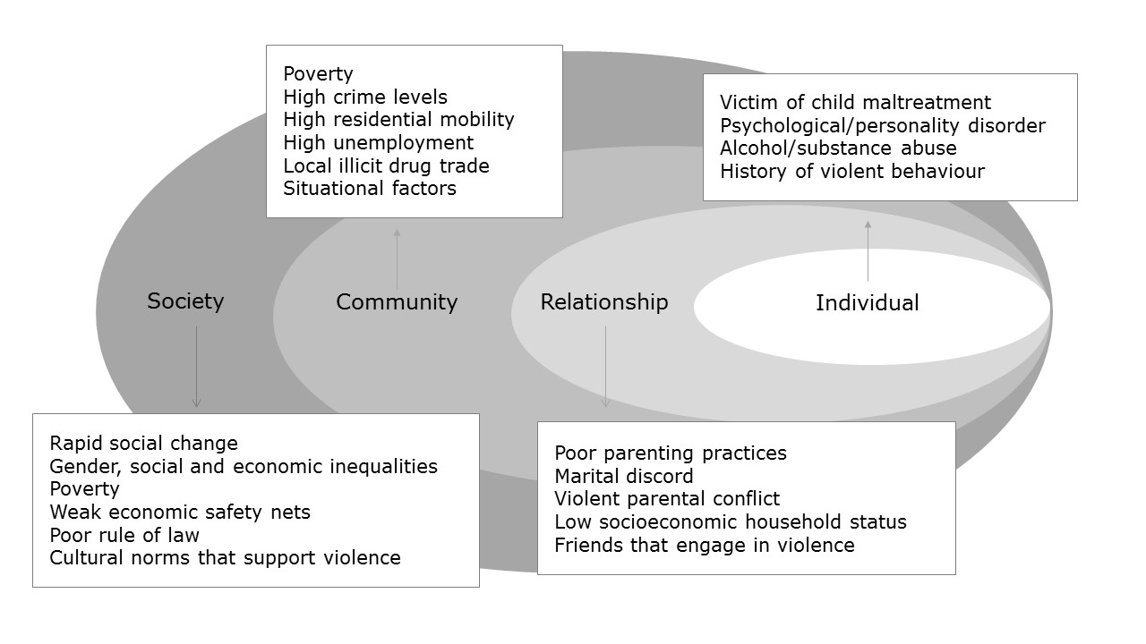
Since the early stages of its development, the ecological model has been noted for its strength in directing our attention beyond individual level factors to consider the wider environment and how this might influence violence exposure. However, it has taken some time for measurement strategies to catch up with this wider understanding of the potential factors that can influence IPV experience. For example, while informed by the ecological model in 2002, the World Report on Violence and Health¹⁶ identified relatively few community or societal level factors associated with IPV which were substantiated by data, largely because few studies measuring community and societal level factors had been conducted at that time.
As conceptual models develop, a wider lens evolves and we have clearer ways of expressing what factors we think are relevant. For example, Heise has further developed the ecological framework for interpersonal violence and expanded it for application to IPV based on empirical research that has been conducted between 2002 and 2010 (Figure 2). In this revised model, the more general concepts defined for the general area of interpersonal violence have been further defined for the specific area of IPV. For example, the 2002 version, which identified ‘cultural norms that support violence’ as a risk factor for interpersonal violence perpetration has been further refined to identify ‘discriminatory family law’, ‘ease of divorce for women’, ‘legal or moral sanction of violence’ as risk factors for IPV. The further specification of these concepts means they can be more effectively targeted through actions such as improved justice responses and identification of what community norms need to be changed.
Figure 2: Drawn from Heise 2011 (p.7)¹⁷
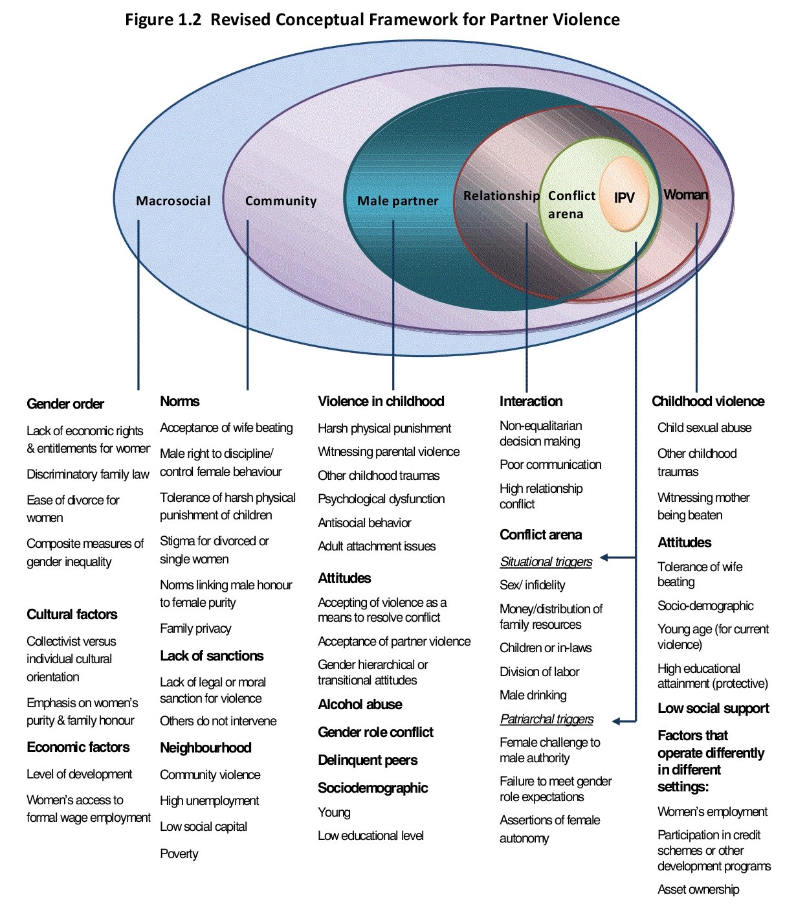
Heise has also expanded key components of the ecological model (within the ‘Male partner’ and ‘Relationship’ layers) and combined these with a timeframe component, to conceptualise a life-course pathway for the development of IPV perpetration (Figure 3). The figure contains three parallel developmental pathways, with links between each. This indicates that for any given perpetrator, one of these developmental pathways may be more salient than the others. The figure sites the developmental pathways within an environment created by macro-social and community level factors. Although the macro-social and community level factors are not actually specified within this conceptual model, it is apparent that interventions that influence the macro-social and community factors have the potential to also influence the developmental trajectory for violence perpetration.
Figure 3: Drawn from Heise 2011 (p.32)¹⁷
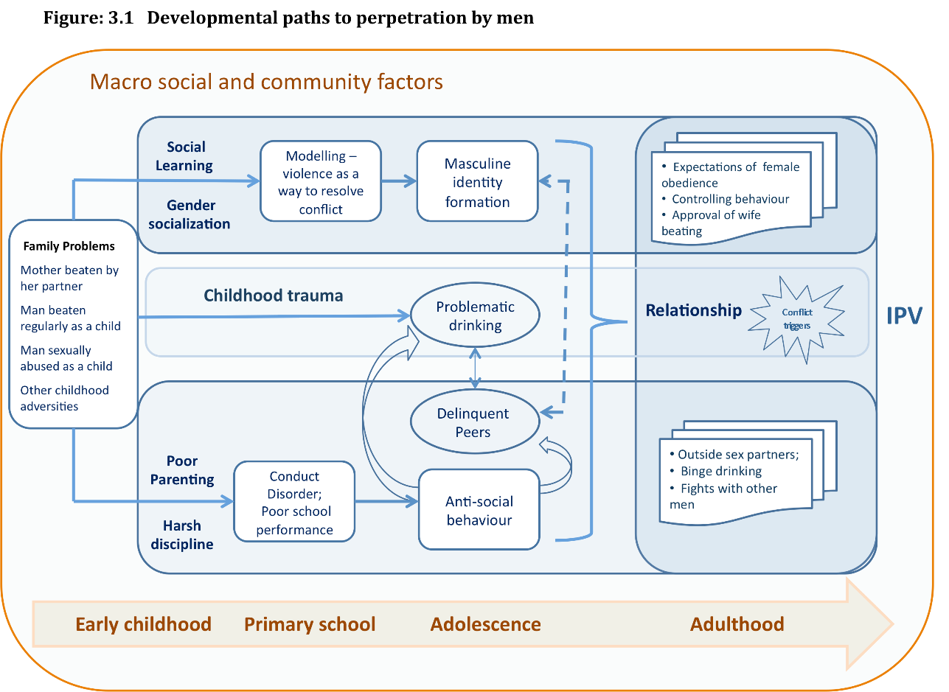
Although the ecological model as depicted by the Violence Prevention Alliance (Figure 1) is one of the most commonly referenced models within IPV research, it is not the only conceptual model which can guide our understanding of risk and protective factors for IPV. In 1994, Nancy Krieger proposed an eco-social framework to integrate social determinants of disease disparity into models of public health.¹⁸
Combined with Heise’s ecological model of IPV, the eco-social framework helps to explain the inter-relationships between structural risk factors for IPV, and community or relationship factors. “Stated more generally, a society’s economic, political, and social relationships affect both how people live and their ecologic context, and, in doing so, shape patterns of disease distribution.” (Krieger 2008, p.223¹⁹)
The eco-social model (Figure 4) expands our lens for understanding components of inequality (e.g. inequalities based on class, race and/or sex), which can increase a person’s likelihood of experiencing IPV. The eco-social model also furthers our understanding of the concept of intersectionality, and its influence on IPV experience. In addition, the eco-social framework helps us to disentangle apparently contradictory findings from studies in developed and developing countries where structural inequalities and social norms may be experienced differently, and helps us to understand the influence of inequalities on life-course risk of violence experience (this point is expanded upon further, below).
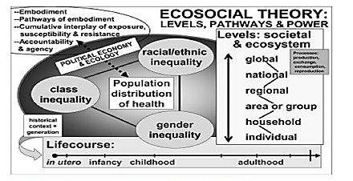
Figure 4: A diagrammatic representation of the eco-social theory (from Krieger 2008¹⁹)
There are also models developed in New Zealand that are more culturally specific and developed from Māori, Pacific, and other worldviews. For example, Transforming whānau violence: A conceptual framework²⁴ takes a strengths-based approach and seeks to move to a place of mauri ora (wellbeing):
“It is regarded as the maintenance of balance between wairua (spiritual wellbeing), hinengaro (intellectual wellbeing), ngakau (emotional wellbeing) and tinana (physical wellbeing). Mauri ora is sustained and restored by experiences of ihi (being enraptured with life), wehi (being in awe of life), and wana (being enamoured with life) … Violence damages wairua, Ngakau and tinana. It disturbs ihi, wehi and wana.” (p.15)
Additionally, Nga vaka o kaiga tapu: A Pacific Conceptual Framework to address family violence in New Zealand²⁵ highlights the importance of acknowledging of how Pacific peoples (including Cook Island Māori, Niuean, Samoan, Tokelaun, Tongan and Tuvaluan communities) understand wellbeing, and takes a strengths-based approach to protecting family wellbeing. This framework also highlights the need to develop comprehensive understandings of traditional worldviews, including values, the principles of respectful relationships and the importance of connections and relationships.
In an effort to map out the on-going impact of colonisation on the intergenerational nature of violence, Smith²⁶ has drawn on the work of Atkinson²⁷ and Hosking et al²⁸ to overlay colonisation on the ecological model (Figure 5).
Figure 5: Understanding the relationship between colonisation and violence experience (from Smith 2015²⁶)
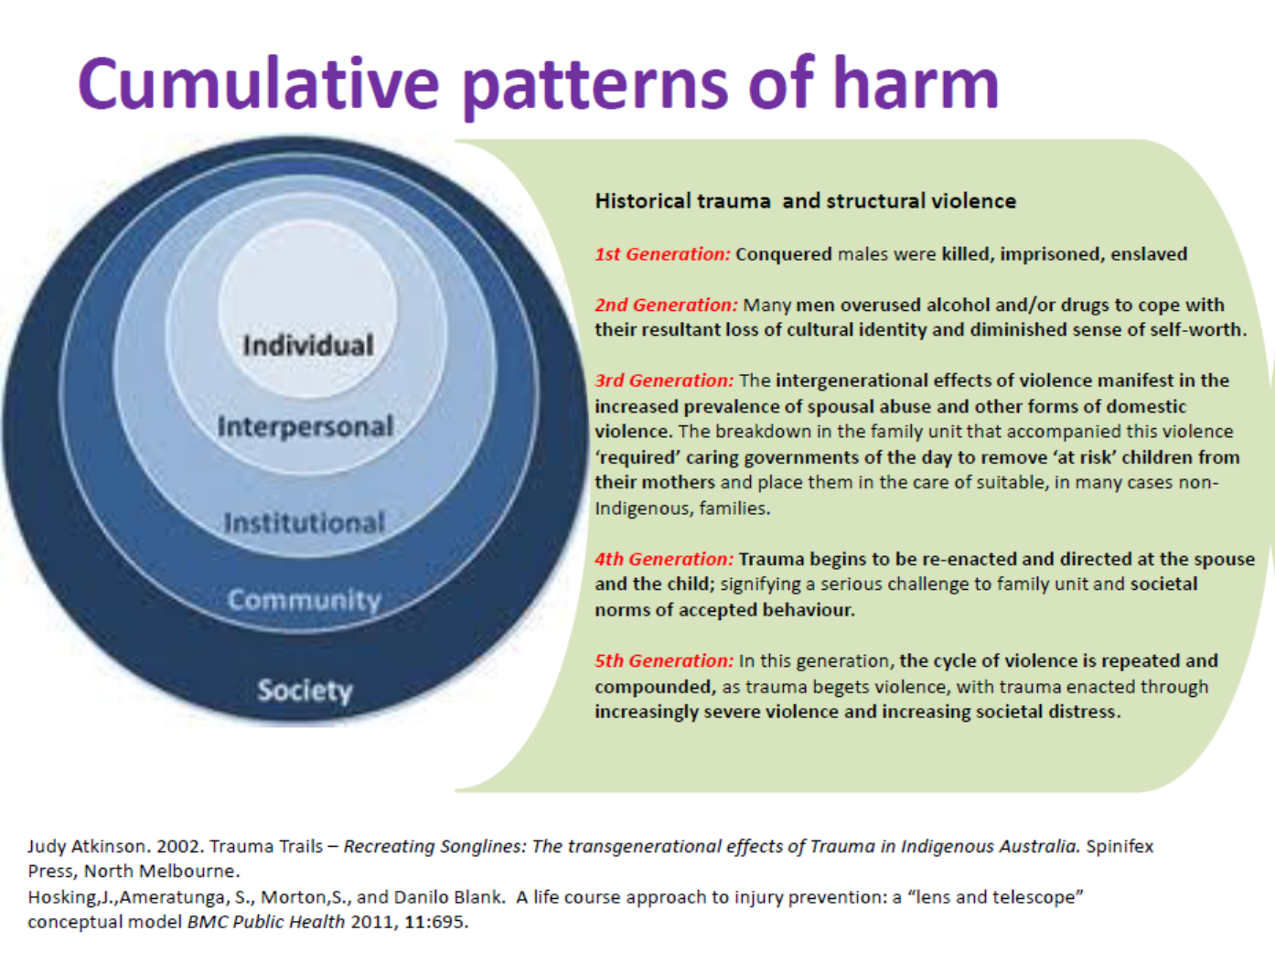
In summary, conceptual models help researchers to specify more clearly the areas they are interested in. Conceptual models also provide a filtering tool, without which there would be no boundaries for research. Although conceptual models may help researchers to identify the factors that relate to IPV in theory, suitable measures do not always exist to determine if the hypothesised relationships really exist. Therefore, one of the reasons that an exhaustive or definitive list of the risk and protective factors for IPV does not exist is that the research community has only recently started investigating macro-social factors from the ecological model, and are only starting to scratch the surface of the eco-social model.

Characteristics of studies that have shaped our understanding of risk and protective factors
Within this section we cover three main types of investigations that have been conducted to identify risk and protective factors for IPV: ecological investigations, cross sectional studies and cohort studies. Definitions for each type of these investigations are provided in the Glossary, at the start of this Issues Paper.
Ecological investigations help to determine the macro-social and community level factors associated with IPV experience or perpetration (the two outer rings of Heise’s expanded ecological framework). Cross-sectional and cohort studies provide evidence concerning how the characteristics of individuals (or relationships between individuals) are related to IPV experience (the four inner rings of Heise’s expanded ecological framework).
In ecological investigations, prevalence or incidence rates between countries or communities are compared and the investigators seek to understand the factors that may be influencing differences at the national or community level. For example, there has been a cross-national comparison of the World Health Organization series of population based studies on violence against women. This study identified that male authority over female behaviour, acceptance of social norms justifying the physical abuse of women by their husbands, and the extent to which women were disadvantaged relative to men in access to land, property and other economic resources were related to IPV.²⁹ In 2011, to highlight the laws and justice response necessary to ensure violence against women is responded to effectively, UN Women conducted an international comparison of the rates of physical and sexual IPV, with women’s political rights, economic opportunities and reproductive health. The report found that laws can play a positive role in shaping society by creating new norms and helping to shape social change. In countries where laws prohibiting domestic violence exist, prevalence was lower and a smaller proportion of the population considered violence against women acceptable.³⁰
As with any research field, early studies of IPV tended to be those from which information about possible risk and protective factors were generated relatively swiftly, driven by the desire to reduce impact. For example, the World Health Organization series of investigations of violence against women are a series of country specific, cross-sectional studies that provide population-level information on risk and protective factors that influence IPV experience.³¹ The New Zealand Violence Against Women study was carried out in 2003, based on the World Health Organization’s survey tool.
In cross-sectional studies, a sample of people are recruited to be representative of the population of interest. Information is collected from this sample, and the characteristics of the people with the outcome of interest (IPV experience or perpetration) are compared with the characteristics of those without the outcome of interest. Differences between the two groups are considered risk or protective factors. A list of factors shown to be associated with increased and reduced likelihood of experiencing current (previous 12 months) as opposed to previous (within lifetime, but not in previous 12 months) IPV identified from the NZ Violence against Women study are presented in Figure 6.
Figure 6: Factors associated with increased (or decreased) likelihood of experiencing current, as opposed to previous IPV³²
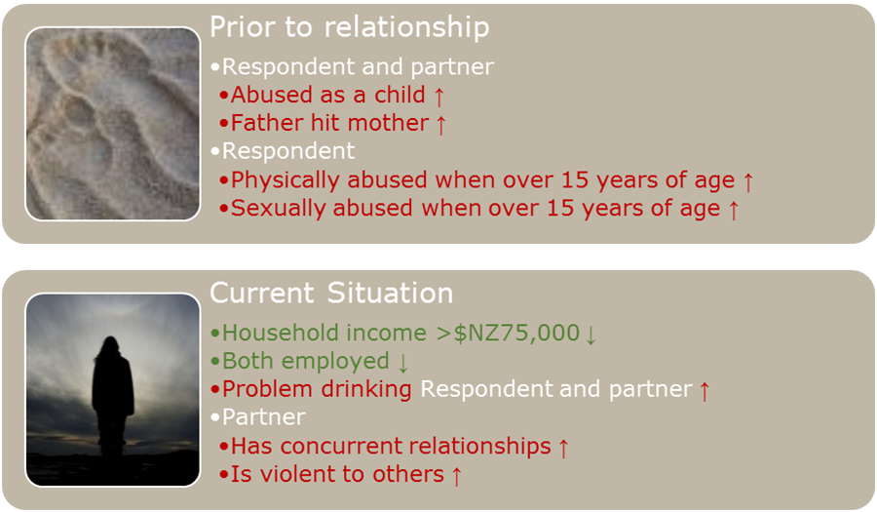

Although cross-sectional studies are one of the most frequently used methods to identify risk and protective factors, they do not provide us with information about the direction of causality, they tell us only that the characteristic and the outcome are associated. Take, for example, the relationship between IPV experience and depressive disorders, as described by Devries and colleagues (Table 1).³³ They note that:
“While it is easy to assume that IPV is causally related to subsequent depression and suicidal behaviour, evidence suggests a more complex relationship. There are three modes of association, which are possible in any combination: (1) IPV exposure causes subsequent depression and suicide attempts, (2) depression and/or suicide attempts cause subsequent IPV, and (3) there are common risk factors for both IPV and depression and suicide attempts that explain the association between them…”
Table 1 provides a description of the mechanisms involved for each direction of causality. To disentangle the direction of the relationship between depression and IPV will require a longitudinal study in which the hypothesised risk factor (which in this case could be either depression or IPV) is measured prior to the outcome.
Table 1: Example of the complexity of relationships that can exist between associated variables: Depression and IPV
Nature of relationship | Possible mechanism
IPV exposure causes subsequent depression and suicide attempts | IPV leading to traumatic stress, which may subsequently lead to depression and suicide attempts
Depression and/or suicide attempts cause subsequent IPV | Depressive symptoms may influence partner selection, resulting in acceptance of partners with poor impulse control, conduct disorders, or other factors increase the likelihood of violence
Common risk factors for both IPV and depression and suicide attempts that explain the association between them | Developmental and early life exposures to violence and other traumas may also play a role in predicting both violence and depression
Cohort studies can provide information about direction of causality, because information on a risk or protective factor can be collected before the outcome of interest. In a cohort study, a group of people (the cohort) are recruited at one point in time. Information is collected at the start of the study on risk and protective factors, and then at regular intervals over time. Outcome measures are also undertaken at regular intervals. Because information on the risk or protective factor is gathered before the outcome occurs, it is easier to establish the direction of causality (i.e. that IPV exposure results in depression, rather than depressive symptoms increasing the likelihood of partnering with a violent individual). Figure 7 (below) provides a basic outline of a cohort study.
Figure 7: Basic outline of a cohort study
Population
Cohort
Exposed
Unexposed
Develop outcome
Do not develop outcome
Develop outcome
Do not develop outcome
Time
While cohort studies provide robust methods for understanding causality, they have limitations in the study of violence. Firstly the length of time required before information about the nature of the relationship between potential risk or protective factors and the outcome of interest can be determined can be quite long. For example, when seeking to understand the relationship between child maltreatment and later perpetration of IPV in young adulthood, 15-20 years is required between the first data collection point and observation of the outcome of interest. Secondly, there is the ethical issue of needing to provide treatment or support to people who are identified as having a particular problem during the course of the study. Providing the intervention or support can then reduce the likelihood of developing an outcome, which is important for the person, but which can affect study results. Thirdly, the success of cohort studies is dependent upon people within the cohort being available for follow-up in the years after the study sample has initially been recruited. There is the potential for people who experience violence to be more likely to be lost to follow-up as a result of no longer being contactable, not wishing to, or not being able to participate in the research.
Fourthly, because IPV research is such a young field, there are few cohort studies that were designed specifically to understand early life factors that are predictive of enhanced or reduced likelihood of IPV experience or perpetration. For example, the Dunedin and Christchurch health and development studies were both initiated in the 1970s. While both of these studies have been able to provide information on early life adversities and their relationship with subsequent IPV experience, information on child maltreatment was not collected until either of the cohort participants were between 16 and 20 years of age. At this time, study members were asked to recall their maltreatment experience during childhood, which is a less reliable method of establishing causality, and more akin to the methods used in cross-sectional studies. Similar situations exist for longitudinal studies conducted in other countries.³⁶
There are one or two exceptions. In 2006, Widom and colleagues reported on a cohort study designed to understand the relationship between child maltreatment and violent criminal behaviour in early adulthood, and whether either early aggressive behaviour (prior to age 15) or problem alcohol consumption (measured in early adulthood) explained the relationship. The results showed that no one factor explained the relationship between child maltreatment and violent arrests, but the authors suggested that early interventions should be considered to reduce the likelihood of abused children developing aggressive behaviours and alcohol problems.³⁷ The authors noted that they only considered two potential pathways – that of early aggression and problem alcohol consumption, and were therefore limited in their ability to explain the relationship between child maltreatment and violent behaviour. This is an example of a limitation linked to their underlying conceptual model.
One advantage of cohort studies is that they offer potential to look for associations between factors that have not previously been considered, simply because the information is available. This is because the expense involved with setting up a cohort study means that the group of people recruited to participate are often subjected to a number of different tests, led by a team of researchers representing a number of different disciplines. For example, while there has been less focus on molecular epidemiology techniques in much of the IPV research conducted to date, preliminary evidence from the Dunedin Multidisciplinary Health and Development Study suggests that genotype expression (the expression of a child’s genetic make-up) may explain why some children who are maltreated go on to perpetrate violence while others do not.³⁸ Subsequent research has shown that expression of the gene (how it influences a child’s behaviour) can be influenced by environmental factors (such as poor behavioural modelling, inadequate social references and inconsistent support for positive decision making). Once again, this reinforces the importance of considering an individual’s risk factors within the context of the macro-social and community risks they are also exposed to.³⁹ This is an example of eco-epidemiology at work.

Difficulties in measurement
In addition to the complexities of determining how risk and protective factors play out under different societal conditions, and across different development trajectories, sometimes we also have difficulties measuring different aspects of violence experience. For example, coercive control has been considered a key feature of IPV for over 30 years. Evan Stark coined the term “coercive control” as a way to explain “how men entrap women in personal life.”⁴⁰ Coercive control is often described as a pattern of behaviour used by perpetrators of IPV, which takes away the victim’s freedom and their sense of self (a liberty crime, as described by Stark).⁴⁰ While physical and sexual violence may or may not be used as a component of coercive control, hallmarks of such behaviour is that it is context specific, involving isolation, degradation, mind-games and micro-regulation of everyday life according to his perception of how she should behave towards him, how she should cook, house-keep, mother, perform sexually, and who she socialises with. In an essay to highlight “the complexities inherent in analyzing coercion in the context of a domestic violence victim’s decision making process” (p.5), Tamara Kuennen states that “In trying to understand the dynamics of coercive control, context is everything” (p.17) – context provides meaning to an abuser’s behaviour.⁴¹ Similarly, Dutton and Goodman state that “not only is context required to understand the nature of coercive behaviours and responses to them, but it is required even to determine when a particular behavior should be considered coercion at all” (p.747).⁴²
As such, coercive control has proven difficult to measure accurately at the population level. In the interim, however, we need to develop flexible systems that are capable of responding to the unique needs of individuals. Ellen Pence, co-founder of the Duluth Domestic Abuse Intervention Project (DAIP), described the importance of asking individuals seeking help about the circumstances of their violence in ways that allow them to tell their own stories, rather than having helpers being reliant on specific risk assessment tools.⁴³ Relatively open ended questions, rather than or as well as specific risk assessment tools, would allow individuals to describe their specific circumstances, so responders can start to help address these appropriately. Further work is also required to understand the frequency, types and context of coercive, controlling behaviours that occur across the population, in order to help us develop more nuanced population-based prevention strategies to address these.

Understanding ‘cause’
While some variations exist, there has been consistency in findings from studies from across the world which has resulted in an enhanced understanding of factors that are associated with the experience or perpetration of IPV (see Appendix for examples of review studies in this area). However, what is less clear is how these factors interact and the direction of causality for any given factor.
Epidemiologists refer to four types of causal relationships:
- Necessary: the outcome only occurs if the causal factor occurs
- Sufficient: the operation of the causal factor always results in the outcome
- Both necessary and sufficient: the causal factor and the outcome have a fixed relationship, neither occurs without the other
- Neither: the operation of the causal factor increases the frequency of the outcome, but the outcome does not always result, and the outcome can occur without the operation of the causal factor.⁴⁴
Current evidence suggests that there are neither necessary nor sufficient risk factors for perpetration or victimisation of IPV. Unlike biological pathways of causation linked with health outcomes (where in the right environment, a virus exposure will result in a disease occurrence), violence is a behaviour, and as such is always governed by some element of choice. If violence is governed by choice, we will never discover necessary or sufficient causes, and the best that we can hope for will be to identify patterns of association that influence the likelihood of violence occurring, and work to address these. Rather than being despondent about this, however, this should actually give us cause for hope, as decisions and subsequent actions have the potential to be more malleable than genetics or other biological determinants.
“If violence is governed by choice, we will never discover necessary or sufficient causes, and the best that we can hope for will be to identify patterns of association that influence the likelihood of violence occurring, and work to address these.”
Understanding that we are looking at socially determined factors that predispose certain behaviours, but which are modifiable by individual choice can help us understand why factors associated with IPV behave differently depending on the familial, social and cultural context. For example, while child maltreatment is strongly associated with both IPV perpetration and victimisation, not having experienced maltreatment in childhood does not mean that a partner will not be violent. Put another way, IPV is also perpetrated in relationships where neither partner was maltreated in childhood.⁴⁵ (This is evident in Heise’s pathway for violence perpetration in Figure 3.) Where a child was not exposed to violence, it may be that the social learning and gender socialisation pathway is more salient than the childhood trauma or poor parenting pathways. As such, these pathways would be more important for interventions that seek to impact on the likelihood of the intergenerational transfer of violence. Work to identify modifiable points in societal attitudes about acceptable behaviours (e.g. use of violence, gendered identity and gender roles), and to understand how these are shaped along developmental pathways becomes a key element in understanding how to modify these pathways.
As another example, one of the most consistent findings across and within countries is that violence, especially IPV, occurs more frequently where there are power inequalities.⁴⁶ These power inequalities can be experienced both within a relationship and within the social and political environment within which that relationship exists.⁴⁶ Where both a woman and her male partner are employed in a high income country such as New Zealand, there is decreased likelihood that the woman will report experiencing physical or sexual IPV in the previous 12 months.⁴⁷ However, in developing countries, when a woman who exists in poverty is offered employment opportunities or training that could lead to employment, there is increased likelihood that she will experience physical or sexual IPV.⁴⁸ Theoretical frameworks can help us to interpret and explain these apparent contradictions.
“violence, especially IPV, occurs more frequently where there are power inequalities”⁴⁶
For example, exploring the relationship between existing cultural norms and structural inequalities can further our understanding of the relationships between employment opportunities and violence experience. Drawing from both the eco-social and the ecological model highlights that the acceptability of what is happening within the relationship (e.g. relative employment status of each partner) is influenced by wider cultural norms and inequalities or opportunities. Understanding these interactions can provide an explanation for the apparently contradictory findings concerning employment and violence experience that exist between high income and low and middle income countries (as people experiencing poverty in developing countries are likely to be living within an environment of greater class and racial or ethnic inequalities⁴⁹). In this context, a man may experience a power deficit as a result of structural inequalities that exist, for example if he is unemployed or earns a low wage. He may choose to regain (or express) power and control within the family environment, an outcome that is rendered more likely in a community where there are accepted gender inequalities.⁴⁹ In this context, his wife gaining employment may be perceived as further eroding his power, this time from within the family environment.⁴⁶ This sequence of events may result in a perceived need to recapture some of the power and control within the family environment through violent means.⁴⁰
In contrast, where there is relatively high social acceptance of female employment (as may be the case in New Zealand), it is possible that a woman’s employment is more likely to be expected, and so does not result in a perceived power imbalance within the family.

The need for a comprehensive, multi-pronged approach to address IPV in New Zealand
While significant steps have been made in developing an understanding of the individual, relationship, community, social and cultural factors that increase or reduce the likelihood of IPV being experienced or perpetrated, our understanding of the pathways to perpetration or victimisation are far from complete. Risk and protective factors that have been elucidated touch on every level of Heise’s ecological framework (Figure 2) and Krieger’s eco-social framework (Figure 4). As such, to focus on any one factor in isolation in the hope that it will address the problem of IPV will be unsuccessful.
Comprehensive, multipronged approaches are required to address IPV, aligned with a long-term investment in policy, infrastructure and communities. Such an approach also needs to be supported by an overall strategic government framework for addressing IPV. An analogy can be drawn with the experience of reducing the road toll burden in New Zealand (Box 1). Although IPV is more complex and less open to legislative control than driving, a similar approach needs to be taken to address the multitude of risk factors that contribute to IPV victimisation and perpetration.
“to focus on any one factor in isolation in the hope that it will address the problem of IPV will be unsuccessful. Comprehensive, multipronged approaches are required to address IPV, aligned with a long-term investment in policy, infrastructure and communities.”
Box 1: Interventions required to reduce the road toll in New Zealand
Early research highlighted the intersection of engineering (road and car design), environment (adverse weather conditions) and personal risk factors (young age, alcohol involvement, lack of experience) that contributed to New Zealand’s high road toll. Government frameworks acknowledged that improved road design, on its own, would not reduce the road toll and could, in fact, contribute to an increased road toll as a result of people driving faster on well-designed roads. Therefore a multi-pronged approach was used:
- Investment in the roading infrastructure (improving road design)
- Legislation to reduce risk – increasing the age of licensure and making drinking and driving illegal
- Social marketing campaigns to highlight how risk factors contributed to increased risk and change social norms around responsible driving
- Working with car manufacturers to improve car safety
- Swift and sure punishment where laws were broken (booze buses, demerit points, speed cameras)
- Increased activity at high risk times, generally when more cars were on the road, to enforce legislation.
The approach was also regularly evaluated and a surveillance system was put in place to determine the success of the combined actions. Substantial gains were made in the early stages, as the ‘low-hanging fruit’ was picked. In time, New Zealand learned how these interventions could be improved by observing increased gains that other countries obtained through improving on the Graduated Driver Licensing System and altering the urban environment to improve driver safety.
On pages 22-26, we have mapped some of the types of interventions required to address IPV in New Zealand. The suggestions are based on Heise’s extended ecological framework and also incorporate aspects of Krieger’s eco-social framework, and aspects of the Whānau Ora / family wellbeing indicators from Superu’s Families and Whānau Status Report.⁵⁰ As such, it is important to note that these figures are based on current knowledge, and are therefore not intended to be comprehensive. The intention of detailing these suggestions is not to provide a menu of alternatives that could be selected from, but to highlight the breadth of activities necessary to begin to address IPV. To address and prevent IPV and other forms of family violence requires a wide range in activities that need to be mutually reinforcing, to support rather than undermine each other.
Key points to note from the diagrams:
Working to prevent violence is a strategic decision.⁵¹ Exposure to IPV, child maltreatment and other forms of family violence has significant and wide ranging effects. Addressing the risk factors for IPV has the potential to impact on health, social, educational and justice outcomes as well as on the experience of violence (Figure 8). By acting to reduce violence, there is the potential to improve mental, physical and relationship health for individuals, families, whānau and the country as a whole. By seeking to address macro-social factors that enhance the likelihood of violence (such as power imbalances related to various forms of oppression), we also have the opportunity to create a fairer society. (continued on page 27)

Over-arching government framework for addressing IPV, including:
Historical determinants
Acknowledge and address the impacts of colonisation
Acknowledge and value traditional whānau, hapū and iwi structures
Culturally appropriate interventions (e.g. kaupapa and tikanga Māori)
Acknowledge and address structural barriers to ensuring adequate social capital
Structural determinants
Acknowledge and address gender inequality in NZ society
Understand and address the structural barriers to safety for those experiencing violence
Work to eliminate discrimination, in all forms
Consider the impact of wider legislative change on violence exposure (e.g. increased alcohol availability is associated with increased exposure to violence)
Effective infrastructure to support and respond to the framework, including:
A well-trained and well-funded workforce, including
those who are intimately involved with IPV and have a responsibility to act (police, social workers, judges)
those who are involved at the periphery, but whose decisions also impact on IPV exposure, such as government agency staff involved in policy development, teachers and hospital clinicians
Effective and coordinated response services
Commitment to long term, multi-generation, funding
On-going surveillance, evaluation and improvement of initiatives
Learning from best practice at an international level

Macrosocial risk factors for IPV experience (Heise)
Gender order
Lack of economic rights and entitlements for women
Discriminatory family law
Ease of divorce for women
Composite measures of gender inequality
Cultural factors
Collectivist vs individual cultural orientation
Emphasis on women’s purity and family honour
Economic factors
Level of development
Women’s access to formal wage employment
Additional macrosocial considerations from Kreiger
Risk of violence heightened where power imbalances exist

Macro-social activities to address IPV

Social marketing campaigns to address:
Social norms regarding gender roles and violence
Opportunities for interventions
Enhanced justice response to IPV
Swift and sure response for perpetrators
Systems that assist victims through legal and social process to get to a point of safety
Community development
Resources – quality and availability
Enhance community engagement and reduce social isolation
Building the community capacity to work together and address common needs (social capital,
includes informal helping, bystander interventions)
Reduce the likelihood of community violence through community development and
enhancement activities
Improved employment opportunities and income support in low socio-economic areas
Enhance Māori social capability
Enhance collective unity
Connected, safe and supported whanau
Meaningfully engage with Māori culture and Māori institutions
Enhance social support for marginalised communities
Community activities to enhance social connectedness

Community risk factors for IPV experience (Heise)
Norms
Acceptance of the physical abuse of women by their husbands
Male right to discipline / control female behaviour
Tolerance of harsh physical punishment of children
Stigma for divorced / single women
Norms linking male honour to female purity
Family privacy
Lack of sanctions
Lack of legal or moral sanction for violence
Others do not intervene
Neighbourhood
Community violence
High unemployment
Low social capital
Poverty
Additional community considerations from Kreiger
Community economy
Community resource accessibility and quality
Community activities to address IPV

Acknowledge and address trauma of violence experienced in childhood
Address the trauma of the direct experience of physical, sexual violence, emotional
abuse or neglect
Address learned experience from IPV exposure
Development of pro-social behaviours and attitudes in childhood and adolescence
(ongoing throughout development)
Challenging patriarchal attitudes
Interventions to change the trajectory where delinquency may exist
Enhancing educational outcomes and employment opportunities
Effective role models
Non-violent methods of conflict resolution
Effective relationship development
Communication strategies
Positive masculinities
Reduce the social acceptability of binge drinking and culture of alcohol dependence
Male partner risk factors for IPV perpetration (Heise)
Violence in childhood
Harsh physical punishment
Witnessing parental violence
Other childhood traumas
Psychological dysfunction
Antisocial behaviour
Adult attachment issues
Attitudes
Accepting of violence as a means to conflict resolution
Acceptance of partner violence
Gender hierarchical or transitional attitudes
Alcohol abuse
Gender role conflict
Delinquent peers
Sociodemographic
Young
Low education level

Additional considerations for men from Kreiger
Need to consider the cumulative interplay of exposure, susceptibility and resistance
Consider class and racial or ethnic inequalities in experiences of power imbalances
Impact on future generation(s)
Activities directed at men

Acknowledge and address trauma of violence experienced in childhood
Address the trauma of the direct experience of physical, sexual violence,
emotional abuse or neglect
Address learned experience of IPV exposure
Development of pro-social behaviours and attitudes in childhood and adolescence
(ongoing throughout development)
Challenging gender hierarchical beliefs
Interventions to change the trajectory where delinquency may exist
Enhancing educational outcomes and employment opportunities
Effective role models
Non-violent methods of conflict resolution
Effective relationship development
Communication strategies
Reduce the social acceptability of binge drinking and culture of alcohol dependence
Enhance opportunities for continued social support
Enhance social capital

Female partner risk factors for IPV experience (Heise)
Childhood violence
Child sexual abuse
Other childhood trauma
Witnessing mother being beaten
Attitudes
Tolerance of the physical abuse of women by their husbands
Sociodemographic
Young age
High academic achievement (protective)
Low social support
Factors operating differently in different settings
Women’s employment
Participation in credit schemes or other development programmes
Asset ownership
Additional considerations for women from Kreiger
Interaction of class, culture or ethnicity and gender inequalities
Cumulative interplay of exposure, susceptibility and resistance
Impact on future generation(s)
Activities directed at women

Accessible and available relationship counselling services to address:
Equalitarian decision making
Strategies for managing relationship conflict
Challenging gender hierarchical beliefs
Development of behaviours and attitudes in childhood and adolescence (ongoing throughout development)
Non-violent methods of conflict resolution
Effective relationship development
Communication strategies
Resilient whānau
Able to overcome adversity and achieve aspirational goals
Can navigate barriers to success
Are able to access material and non-material resources
Able to live well and manage economic security
Whānau support each other to succeed

Relationship risk factors for IPV experience (Heise)
Interaction
Non-equalitarian decision making
Poor communication
High relationship conflict
Conflict area(s)
Sex / infidelity
Money / distribution of resources
Children or in-laws
Division of labour
Male drinking
Female challenge to male authority
Failure to meet gender role expectations
Assertions of female authority
Additional relationship considerations from Kreiger
Consider the impact of the wider social, economic and political environment on relationships
Understanding the functioning of relationships develops over the life-course
Activities directed at families, whānau and relationships
Even though we don’t have information on all potential risk and protective factors, we do have enough information to start acting to prevent IPV. Lessons can be learnt from other jurisdictions and other ‘wicked’ problems. For example, while acknowledging that not everything is known about how to prevent child abuse and maltreatment, the United States Centers for Disease Control have produced a technical package to describe effective, promising or prudent practice. Alongside the recommended interventions is a commitment to continue with research and evaluation to inform programme planning, implementation and monitor programme impact and progress. As such, the technical package is a living document, as it is acknowledges that further work is required in this area.⁵²
A similar process can be undertaken in New Zealand for both child maltreatment and IPV, as we have sufficient information now to (a) design and invest in systems that are capable of working to alter and address social norms (prevention system); (b) design systems that are flexible and capable enough to respond to the unique needs of individuals (intervention systems); and (c) continue to commit to finding out more about population level patterns where our understanding is not well developed, including to develop further knowledge about controlling behaviours and potentially modifiable social norms. Committing to this process will require:
- Sustainable and flexible funding packages that can be used to respond to the unique characteristics of communities and individuals, acknowledging that there is unlikely to be a ‘one size fits all’ solution;
- Integrated, collaborative approaches; and
- Workforce development.
Seeking to address one (or a limited number) of risk factors at either the community or individual level will only get us so far. However, as long as an initiative is connected to the bigger picture and recognising the need to act on multiple fronts, tackling a limited number of risk factors at a community or individual level will make a start. An analogous example is the approach taken by Friends of the Earth in 1969, the slogan for which was “think globally, act locally.”⁵³ The phrase is an acknowledgement that environmental issues are a global problem which need to be tackled at multiple levels. Similarly with IPV, individual behaviour changes need to be supported by changing social norms and seeking to drive down multiple forms of oppression. Such macro-social changes are unlikely to fully occur in one generation, yet changing an individual’s behaviour can occur in the short term and can add momentum to changing social norms.
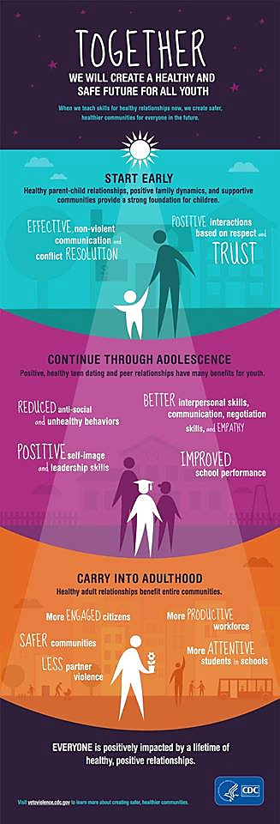
In fact, the IPV community may have much to learn from the experiences of the climate change community. Both IPV and climate change are considered ‘wicked’ problems requiring actions on multiple levels, including structural change and state and legislative controls as well as changing social norms in combination with individual behaviours and expectations (‘individual decarbonisation’⁵⁴). Science communication researchers have shown how positive climate-related behaviour change is easier to communicate and more engaging than negative changes, despite a preponderance of bad news stories run in mainstream media.⁵⁴ This is analogous with the positive behaviour change required to reduce the incidence of IPV (such as building positive, equitable and safe relationships) – instead of individual decarbonisation, the goal is to make a shift in gender (and other social) norms. Reviews of interventions conducted with men and boys⁵⁵ as well women and girls⁵⁶ have shown that gender transformative programmes at multiple levels (group work combined with social marketing campaigns, community activities and supported by policy development) have the potential to lead to positive changes in behaviours and attitudes related to sexual and reproductive health, newborn and child health, interaction with children, use of violence against women and men’s general health seeking behaviour.⁵⁵
Importantly, we need to recognise that the positive effects of this work are not simply limited to the impact on IPV alone, but also will contribute to wider personal, family and social benefits (such as reduced suicide, reduced prison populations, improvements in mental health, improved educational attainment and subsequent employment, see Figure 8).
Figure 8: The benefits of violence prevention⁵⁷

Conclusion
“There is no single causal factor for intimate partner violence that, if modified, will eliminate violence from occurring. Instead, the likelihood of violence being perpetrated or experienced is influenced by a constellation of factors working at a number of different levels, from historical and macro-social factors, to factors unique to the individual.”
There is no single causal factor for intimate partner violence that, if modified, will eliminate violence from occurring. Instead, the likelihood of violence being perpetrated or experienced is influenced by a constellation of factors working at a number of different levels, from historical and macro-social factors, to factors unique to the individual. The development of systemic coordinated ways of working and the widespread implementation of interventions designed to reduce the likelihood of violence has the potential to have wide-ranging, positive benefits, including the creation of a more egalitarian society, reducing barriers that prevent all people in New Zealand society from reaching their full potential.
There are opportunities to learn from the approaches taken to address other health problems. While successful elimination of IPV will require a comprehensive, multi-pronged approach incorporating a long-term view over a number of years, sufficient information already exists to start to address violence experience.

References

Appendix: Further reading
Abramsky, T, Watts, C, Garcia-Moreno, C, Devries, K, Kiss, L, Ellsberg, M, Jansen, HA & Heise, L. What factors are associated with recent intimate partner violence? Findings from the WHO multi-country study on women's health and domestic violence. BMC Public Health. 2011; 11(1):109. Online at: www.biomedcentral.com
Fanslow, JL & Gulliver, P. Exploring risk and protective factors for recent and past intimate partner violence against New Zealand women. Violence and Victims. 2015; 30(6): 960-983. Doi: 10.1891/0886-6708.VV-D-14-00010
Fortson, BL, DeGue, S, Jones, K, Freire, K, Dills, J, Smith, SG & Raiford, JL. Preventing child abuse and neglect : a technical package for policy, norm and programmatic activities. Atlanta, GA: National Center for Injury Prevention and Control, Centers for Disease Control and Prevention, 2016. Online at: www.cdc.gov
Greenfield, EA. Child abuse as a life course determinant of adult health. Maturitas. 2010; 66(1):51-55. Doi: 10.1016/j.maturitas.2010.02.002
Heise, L & Fulu, E. What works to prevent violence against women and girls? State of the field of violence against women and girls: What do we know and what are the knowledge gaps? Annex D. Pretoria, South Africa: Medical Research Council, 2014. Online at: http://r4d.dfid.gov.uk
Jewkes, R. Intimate partner violence: Causes and prevention. The Lancet. 2002; 359(9315): 1423-1429. Doi; 10.1016/S0140-6736(02)08357-5
Kendall-Taylor, N, Lindland, E, O'Neill, M & Stanley, K. Beyond prevalence: an explanatory approach to reframing child maltreatment in the United Kingdom. Child Abuse & Neglect. 2014; 38(5):810-821. Doi: 10.1016/j.chiabu.2014.04.019
Krug, E, Dahlberg, LL, Mercy, JA, ZwiAB & Rafael, L. World report on violence and health (pp.96-100). Geneva: World Health Organization, 2002. Online at: www.who.int
Lamont, A & Price-Robertson, R. Risk and protective factors for child abuse and neglect. CFCA paper. Melbourne, Vic: Australian Institute of Family Studies, 2013. Online at: http://www.aifs.gov.au/cfca/pubs/factsheets/a143921/index.html
Office of the Special Representative of the Secretary General on Violence Against Children. Toward a world free from violence: global survey on violence against children. New York, NY: The Office, 2013. Online at: http://srsg.violenceagainstchildren.org
Taylor, A, Carswell, S, Haldane, H & Taylor, M. Toward a transformed system to address child abuse and family violence in New Zealand: literature review - Part One. Christchurch, New Zealand: Te Awatea Research Centre, University of Canterbury, 2014. Online at: www.esr.cri.nz
WHO & London School of Hygiene and Tropical Medicine. Preventing intimate partner and sexual violence against women: taking action and generating evidence. Geneva: World Health Organization, 2010. Online at: www.who.int

To consider IPV experience only as an outcome and not as a risk factor for further adverse health, social and judicial consequences is to underestimate the effect of violence exposure as a social determinant of health, and as a risk factor for long term health and social inequalities. Indeed, the strong relationship between structural, ethnic and gender inequalities and violence experience highlights how the conditions in which people are born, grow, work, live, and age, and the wider set of forces and systems shape the conditions of daily life.⁸
The concept of “gender based violence” highlights that the violence women experience is shaped by gender role and status in society. “A complex mix of gender-related cultural values, beliefs, norms, and social institutions implicitly and even explicitly have supported intimate partner violence and provided little recourse for its victims” (Russo and Pirlott 2006, p.181)¹²
While the figure does not provide an exhaustive list of all factors shown to be related to violence, it provides an indication of the complexity of the issues. Note that for any given relationship or at any given time, one of these factors may be more salient than others.
The term intersectionality was coined in 1989 and describes the ways in which multiple oppressions are experienced.²⁰ Originally, the term was used to describe the multiple oppressions of sex, race and class for Black women in America.²¹ However, intersectionality has since been adopted to highlight multiple oppressions and marginalisation including in relation to dis/ability,²² sexuality²³ and so on.
It should be noted that there are a number of other types of investigations that can be conducted, and that have been conducted to measure other aspects of IPV (for example, randomised, controlled trials to evaluate the efficacy of interventions). However, a full and detailed description of all possible types of investigation is out of the scope of this paper.
While this study provides insights into some of the risk and protective factors that are associated with IPV in NZ, and can provide us with indications of what preventative or actions may be required, as noted in Section 1, this list only provides data on the risk and protective factors we asked about in the questionnaire, and, as such, is not a comprehensive list.
Social referencing describes how a child will regulate their behavior according to their caregiver’s facial expressions. For example, they may be upset from a trip or fall if a parent exhibits a concerned reaction to the event. Alternatively, if the parent responds in a more relaxed manner because of the benign nature of the trip, the child may exhibit no emotional response.
Note: There is seldom one, single sufficient cause of any health outcome. For example, increased exercise is not sufficient for weight loss. However, increased exercise without increased energy intake is sufficient for weight loss.

