Creating Change: Mobilising New Zealand Communities to Prevent Family Violence
Sheryl Hann¹ & Cristy Trewartha²
¹ Master of Arts (Hons) (Sociology); Bachelor of Arts (Social Sciences)
² Master of Public Health (Hons); Post Graduate Diploma (Psychology); Bachelor of Arts (Psychology); Bachelor of Commerce (Management and Employment Relations)
Key Messages

- Community mobilisation is a complex and long-term approach but has the potential to transform communities.
- Principles of community mobilisation include: a social change perspective; whole community engagement; collaboration; being community-led; and, a vision for a better world.
- Community mobilisation approaches make theoretical and practical sense. As a recent approach, the necessary components of community mobilisation are still emerging, and projects are learning as they go.
- Supporting this work to develop requires thinking in new ways from all involved, from funders and policy makers to NGO leaders, practitioners and community members.
- It also requires some different and sustained investment in coordination roles, workforce development, and new leadership skills.
- Internationally, there are a few examples which show promise in terms of effectiveness, and there are also promising NZ initiatives. However most have not been evaluated. There must be investment in research and evaluation to learn more about what works to create change.
- Findings from international projects indicate that CM efforts can result in substantial reductions in violence in relatively short periods of time, e.g. 2-3 years.

The New Zealand Family Violence Clearinghouse can be contacted at:
New Zealand Family Violence Clearinghouse
Tāmaki Campus
University of Auckland
Private Bag 92019, Victoria Street West
Auckland 1142
New Zealand
Phone: + 64 9 923 4640
Email: info@nzfvc.org.nz
Website: www.nzfvc.org.nz
ISSN: 2253-3222 (online)
Recommended citation
Hann, S., and Trewartha, C. (2015). Creating Change: Mobilising New Zealand Communities to Prevent Family Violence. Auckland, New Zealand: New Zealand Family Violence Clearinghouse, University of Auckland.
Acknowledgements
Thank you to Professor Mandy Morgan (Professor of Feminist Psychology, Massey University) and Rachel Harrison (CAPS Hauraki) for their feedback on earlier versions of this paper. Thank you to all of the community initiatives around New Zealand that have contributed to the development of our thinking about community mobilisation through the sharing of their practice. Thank you to the Clearinghouse team for their feedback and support of this work.
Disclaimer
Sheryl Hann is part of the It’s not OK Campaign team, employed by the Ministry of Social Development, however views expressed in this paper are her own.

Contents
1. Introduction 4
2. What is community mobilisation? 5
2.1 Across the prevention continuum 6
2.2 Across the levels of the ecological model 6
2.3 Rationale for community mobilisation 6
2.4 Phases of community mobilisation 7
3. Principles of community mobilisation 8
3.1 Social change 8
3.2 Whole of community 9
3.3 Collaboration 9
3.4 Community-led 10
3.5 Vision of a better world 11
4. Making it happen 11
4.1 Evidence informed planning 12
4.2 Multifaceted activity 14
4.3 Relationships 16
4.4 Innovation 17
4.5 Principles of behaviour change 19
5. Challenges 21
5.1 Leadership 21
5.2 Time frame 22
5.3 Funding 22
5.4 Services 22
5.5 Skills 23
5.6 Coordination support 23
6. Assessing change 24
6.1 Other ways to assess change 25
6.2 The Community Readiness Model 26
6.3 Theory of Change model 26
7. The way ahead 28
8. References 29

Introduction

“No system can solve New Zealand’s big family violence problem on its own. Individuals, families and whānau, neighbourhoods and communities must have in their hearts the will to embrace change ... [The] prevalence of family violence and its reach into every neighbourhood makes it everyone’s problem. Therefore, everyone has a role to play in eliminating it. Champions don’t need to be celebrities. Small kindnesses can be as powerful as big systems.” – The Glenn Inquiry⁶

New Zealand, like many other countries, is searching for effective ways to turn the tide on the problem of family violence. The enormous costs to individuals, communities and society are too significant to be ignored. While we need specialist services to support people who have experienced or used violence, it is now widely recognised that individualised programmatic responses alone will not stop the harm. The problem of family violence is created and reinforced by multiple factors, but we know that social norms (behaviours and beliefs that are seen as normal or correct) and community attitudes and behaviours can be important risk or protective factors.¹⁰⁻¹³
Community mobilisation (CM) is an approach that builds local leadership and ownership around an issue, enabling community members to change attitudes and behaviours in ways that work for them. Only the active involvement of a broad range of community members will help to create meaningful change around complex ‘wicked’ problems like family violence.¹⁰⁻¹³ CM is a relatively new approach to addressing family violence and there is limited evidence of effectiveness available, but there are some examples that show a reduction in violence.
We know we want to end family violence; this issues paper is focused on how a CM approach can be used to help this happen. The intended audience for this paper is primarily community-based practitioners, but also funders, policy makers, and researchers working to support community mobilisation to prevent family violence. While this paper draws on international literature, it has a strong focus on New Zealand and will highlight a number of local CM initiatives to illustrate community mobilisation principles in practice.

What is community mobilisation?
“[T]he world doesn't change one person at a time. It changes as networks of relationships form among people who discover they share a common cause and vision of what’s possible” – Margaret Wheatley and Deborah Frieze¹⁵
Community mobilisation (CM) is an approach that highlights the central role of community members in addressing complex problems, and shifts the focus of decision-making and action from external organisations to community members, groups and local organisations to determine the best strategies to address their concerns.¹¹
Community mobilisation has been defined as
“A unique, long-term approach which involves a complex and strategic intertwining of (activities) … to enable community members as leaders in changing entrenched social norms”.¹⁶
Michau¹⁶ outlined the key features of CM (see Table 1). While it is not a definitive list, it can be a useful starting point for understanding the approach.
Table 1: Features of community mobilisation¹⁶
Community mobilisation is… | Community mobilisation is not…
Systematic and long-term programming | Ad hoc, one-off activities in short-term projects
Fostering alternative social norms | Transferring information and facts
Complex and multifaceted | A singular strategy
A struggle for social justice | A technical quick-fix
About fostering activism | About implementing activities or training
Involving a critical mass of individuals, groups and institutions | Possible with few individuals or groups
Stimulating critical thinking | Transmitting simple messages
Holistic and inclusive | Limited to specific individuals or groups
Benefits-based | Punitive
Focused on core drivers | Focused on manifestations of violence
Iterative and organic | Linear and predictable
Community-led | Organisation and expert focused

Across the prevention continuum
Community mobilisation is fundamentally a primary prevention approach because it seeks to change attitudes and behaviours to prevent violence before it occurs. However, it can also include aspects of secondary prevention (addressing early signs or risk of experiencing or using violence) and tertiary prevention (crisis support, and longer term recovery and change) and emphasises the role of community members across the prevention continuum.

Across the levels of the ecological model
The focus of CM is stimulating action at the community level. However effective CM initiatives will also be working at the individual and relationship levels within communities (see Figure 1). Work at the societal level is also important, as CM initiatives can influence policy and law through submissions, presentations and the media, and can influence services and systems by changing practice on the ground and communicating learnings to national bodies.
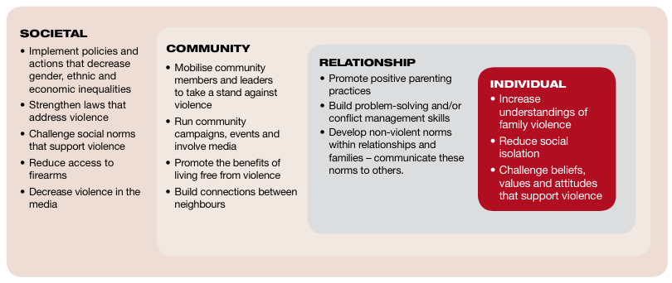
Figure 1: The ecological model with examples of violence prevention activities¹⁷

Rationale for community mobilisation
Due to the complexity and entrenched nature of family violence, community-based interventions are thought to have significant potential to reduce rates of violence and prevent future violence from occurring. Building safe, respectful, equal and caring family and whānau relationships requires engaging within communities, as communities are the places where people’s identities, roles and attitudes are shaped. In communities, we learn what it means to be a parent or partner, and we learn to tolerate or reject violence.
Engaging communities is also important because the majority of victims and perpetrators of family violence do not reach services. Most seek help from friends and family members. Only 13-26 percent of incidents of intimate partner violence (IPV) are reported to Police. This means that the majority of family violence incidents are currently being dealt with by friends, families and communities who may or may not have the skills and knowledge to respond in helpful ways.² To enable these informal systems to work well, it is critical to increase community members’ understanding of the issue.

Phases of community mobilisation
Mobilising a community is an iterative process, which requires phases of action that build on each other. For Raising Voices CM initiative to prevent violence against women (VAW)²⁶ Michau and Naker adapted a model of personal change²⁷ to show the stages of community change (see Table 2 and Figure 2). The model features in the Creating Change toolkit developed by the It’s not OK Campaign,¹⁷ and has been useful for groups in New Zealand developing their initiatives.
Table 2: Phases of community mobilisation
Phase | Description
Community assessment | Gather information on attitudes and beliefs about VAW  Build relationships with community members and professional sectors
Raising awareness | Raise awareness of VAW, causes and consequences
Building networks | Encourage and support community members and professional sectors to begin considering actions and changes to keep women safe, and to support VAW efforts.
Integrating Action | Make actions against VAW part of everyday life, and within institutions policies and practices.
Consolidating efforts | Strengthen actions for prevention of VAW to ensure sustainability, continued growth and progress.

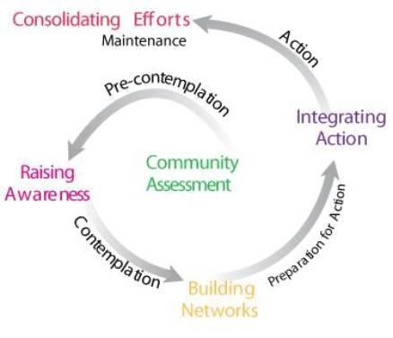
Figure 2: The Phases of Community Mobilisation model²⁶
The model suggests that the actions and activities being planned need to be relevant to how ready the community is to address the issue, and what preparation for action has been completed. The model also helps with thinking about where to start, and when to move to the next stage of action. Although the model demonstrates a linear progression through the phases of CM, in practice, change is usually more complex. An initiative may need to cycle back to an earlier phase before progressing forward.

Principles of community mobilisation
This section describes some the principles of a CM approach.

Social change
Community mobilisation has an explicit focus on creating social change. So while CM initiatives may include awareness raising and education as part of activity, this is not an end in itself. The aim is to shift the norms within the community that mean family violence is accepted and perpetuated. These norms may include male control in the family, sexual domination as a sign of masculinity, physical punishment of children and partners, using violence to solve conflict, shame, and family privacy. Shifting community norms involves a long-term process to develop critical awareness of existing beliefs and practices. Negative norms and practices can in time be replaced with positive beliefs and practices as individuals start to change how they think, and the community starts to cultivate healthy behaviours and environments, creating a ground swell for change.
“Social norm change can only come about if community members spearhead efforts, inspiring one another through courage, negotiation, listening and action” – Lori Michau¹⁶

Whole of community
The New Zealand version of the Coordinated Community Action model (see Figure 3) shows what a whole-of-community approach to family violence could look like. The complexity of the problem requires diverse actions in many spaces. The model illustrates the idea that everyone can do something to help stop family violence where they live, play and work, and encourages people to think beyond just the provision of services.¹⁷
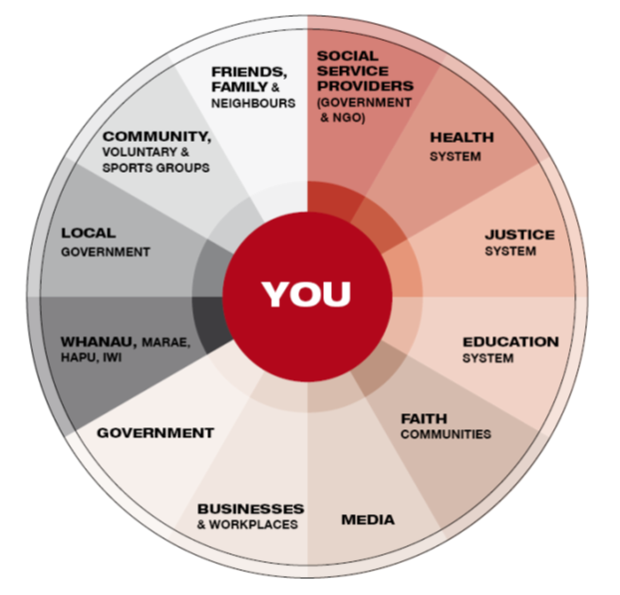
Figure 3: NZ version of the Coordinated Community Action Model¹⁷

Collaboration
“Like a jigsaw puzzle, each piece of a collaboration is important, and only when all of the pieces are put together is the whole picture complete. By working together, coalitions can conserve resources by reducing duplication and sharing expenses, foster cooperation between diverse sectors of society, and increase the credibility and impact of their efforts” – Rachel Davis, Lisa Fugie Parks and Larry Cohen³⁰
Hierarchies, silos or top-down ways of working do not fit well with CM. Collaborative approaches, partnerships, and coalition building are important for “engaging, inspiring and supporting a diverse range of community members, groups and institutions”.¹⁶
The Collective Impact model is one way of understanding how collaboration can achieve change around complex social issues. Collective Impact is based on the idea “that large-scale social change comes from better cross-sector coordination rather than from the isolated intervention of individual organizations”.³¹ Five conditions for Collective Impact success are outlined in Table 3.³¹
Table 3: Collective Impact conditions for success
Condition | Description
A common agenda | A shared vision for change, common understanding of the problem, a joint solution with agreed actions
Shared measurement systems | Collecting consistent data to measure success
Mutually reinforcing activities | Each group undertaking different activities that are coordinated and contribute to common agenda
Continuous communication | Regular communication to develop trust, common language, and collaborative problem solving
Backbone support | A separate organisation/ staff with skills to coordinate, plan and manage the initiative, and provide facilitation, technology, research and communications support.

Resources: Collective Impact video
In the Collective Impact model,³¹ as well as other research,³² having dedicated coordination or project support staff is seen to be essential to success. Collaboration does not just happen, it needs to be supported, resourced and encouraged to thrive.³² Successful CM initiatives require staff who have a primary focus on prevention (rather than services delivery) and have topic knowledge, communication, facilitation, relationship building, promotion, project management, and research skills. In a recent review of community action initiatives supported by the It’s not OK campaign, Roguski found that having a network coordinator dedicated to prevention activity was a key success factor in local efforts to positively change families and communities.⁵

Community-led
“There is no power greater than a community discovering what it cares about” – Margaret Wheatley³³
Community ownership, with meaningful input into the planning and implementation of the project, has been shown to be key to promising strategies for preventing domestic violence. Ideally family violence specialists and community members are in deep conversation where both are learning about the issue and what will work to make change. However, most interventions to address or prevent violence are led by family violence organisations. While CM approaches may be initiated by organisations, the aim should be to transfer leadership to community members as capacity is built.
CM initiatives ideally are developed in response to an issue that community members care about, rather than a decision from outside the community. Rather than ‘doing to’ a community, CM approaches work in partnership to identify a community’s vision, goals and preferred approach. CM challenges the central role of traditional family violence experts, and emphasises the expertise of community members who know their community and what will work locally to make change. This will usually mean that the approach is quite different from what specialist organisations are used to, but may be more effective at engaging the community.
Strong Communities is a successful example of CM in South Carolina. It was a neighbourhood-based strategy for child protection that worked to embed child safety in people’s everyday lives. Outreach workers mobilised hundreds of organisations (e.g. churches, fire departments, businesses) and thousands of community members to build community connections. The goal was to develop new norms of family support and parental care. After seven years evaluation, Strong Communities showed significant reductions in child maltreatment, and significant increases in child safety, social support, and positive parenting practices.¹⁴

Vision of a better world
Family violence is an issue of power, commonly the abuse and misuse of power by men over women, parents over children, and adults over their elders. Family violence intersects with other forms of power, domination and inequalities such as those related to racism, colonisation, homophobia, and ableism. Ending family violence requires responding to injustice, challenging the misuse of power, and “striving for equality, rights and dignity” for all.¹⁶ A CM approach to ending family violence therefore is more than implementing a programme or putting out a message, it ideally includes a social justice approach that seeks to create a better and fairer world. A vision of a better world is also important for keeping CM practitioners focussed and energised.
“Efforts devoid of social justice lens become short term projects rather than sustained movement, enacted by individuals who are personally invested in bringing about a change in her/his community.” – Lori Michau¹⁶

Making it happen
This section looks at CM in more detail, outlining ways of working and conditions that can support successful initiatives. Examples from New Zealand family violence prevention initiatives are included. Each CM initiative is unique in responding to the local risk and protective factors, social, cultural, political and physical environment – there is no one formula that works for all. Ideally there is a process of continuous improvement and reflection, choosing a place to start, and learning what works in a particular context.

Evidence informed planning
Community mobilisation is a systematic approach that draws on public health thinking,³⁵ and an understanding of factors that contribute to violence, to develop multi-layered and long-term actions that will address those factors. CM initiatives ideally start with evidence, and gather data as they go, undertaking evaluative activities so that they can determine whether they are making a difference, what to do more of, and what to let go.
“In an increasingly open and connected world, there are many new opportunities to share ideas, compare data and co-create novel approaches to change. The sources of wisdom may no longer be the perceived ‘experts’ of the past … [but those who] are just a few steps ahead” – Helen Bevan and Steve Fairman³⁶

While being evidence informed is good practice, it may also be necessary to recognise alternative and marginalised sources of information. Being community-led, it is important that CM initiatives seek out and listen to local knowledge and stories, not only relying on mainstream, mainly Western and academic, data sources. Victims in New Zealand, for example, have argued that all family violence initiatives need to be informed by survivor voices and the lived experience of those affected by violence.³⁷ Research by Amokura, a community-based initiative in Northland, highlighted taitamariki (Māori youth) as an important source of knowledge to inform further research and programme development.³⁸ SKIP, a New Zealand positive parenting initiative, found that children’s voices were missing from many of the initiatives developed to keep them safe, and so sought to create ways to allow adults to hear children’s knowledge and views by producing DVDs of children’s perspectives.³⁹

It’s not OK
The It’s not OK Campaign is a national initiative that aims to change New Zealanders’ attitudes and behaviours around family violence. The Campaign uses research, monitoring, evaluation and community feedback to inform and adapt the direction of the campaign, and to understand its impact. For example, the “It is OK to help” phase of the campaign that encourages safe and effective helping by friends, family, workmates and neighbours was developed after seeing a theme emerging from community conversations. Community feedback showed many people felt they should do something, but didn’t know what to do. The Campaign team commissioned primary research on help giving and help seeking, audience tested concepts for TV ads before and after production, engaged experts to advise on any safety issues or unintended consequences around helping messages, and consulted with family violence services. Monitoring research conducted after the launch of the phase in 2011 showed that 31% of those who recalled the campaign had taken action as a result of it. This figure was higher for some groups - 50% of Māori women and men, 45% of Pacific men, and 56% of those who knew someone experiencing family violence took some action. Furthermore 27% of people took preventative action such as talking to children about acceptable and unacceptable behaviours.⁴⁰
Resources: It’s not OK Campaign website and It’s not OK videos

Hauraki Family Violence Intervention Network
The Hauraki Family Violence Intervention Network (HFVIN) is a network of community and government agencies that lead family violence intervention and prevention in the Hauraki-Thames area. HFVIN developed and ran three local family violence prevention campaigns in their area, each one featuring local champions (e.g. sportspeople, school leaders, Police, business owners and community leaders). The first campaign was run in Waihi in 2010. HFVIN used a formal evaluation, reflection and community feedback to learn about the impact the campaign had. Their learnings included: the need to involve the community in planning earlier; ensure local services can pick up increased referrals; gather survey and service data; and, provide more support and training to the local champions.⁴¹ Subsequent campaigns in Paeroa in 2013, and Thames in 2014, were informed by the Waihi campaign learnings. These campaigns were developed after a long process of discussing the issue with their community, and they worked in partnership to develop a vision and actions to ensure initiatives were community owned and supported.
Resources: Paeroa campaign video

Multifaceted activity
“The complex and wicked nature of these issues [partner violence and child abuse] demands that we stop responding as if they were tame problems. They require a different approach than the simplistic ones we have used to date… Given the interconnectedness of these issues, attempting to remedy one in isolation of the other can have unintended negative consequences for these related issues” – Ruth Herbert and Deborah Mackenzie⁴²
Community mobilisation is multifaceted because it involves coordinating a diverse range of actions in multiple settings. Some activity may be more structured, such as a training programme for practitioners and community members. Other activity may be more organic, such as engaging existing leaders and developing new leaders.
Diverse parts of the community need to be activated in a range of ways that are meaningful to them. This means that CM is time-intensive, process oriented, and complex due to the numbers of individuals, groups and organisations involved.¹¹ Capacity building is essential to sustaining the diverse actions stimulated by CM.¹⁰

It’s not OK
In order to support attitude and behaviour change across New Zealand, the It’s not OK Campaign undertakes activities at national and local levels including:
- Mass media
- Communications: website, social media, free resources
- Change champions: people who tell their story of becoming violence-free
- Media advocacy: training journalists and community spokespeople
- Building and supporting the social change workforce
- Funding and supporting local community action.
National messages and branding are complemented by activities that make the campaign “real, relevant and alive” in local communities in a range of settings including neighbourhoods, towns, sports clubs, faith communities, schools, workplaces and councils. Local groups work within the framework provided by the campaign, and tailor family violence prevention messages, resources and activities to suit their context.⁵
“The national campaign has provided a national framework to hang our local initiatives on. It provided a scaffolding for us to build upon” – Family violence coordinator quoted in Roguski.⁵

The HEART Movement
The HEART Movement is a long-term community mobilisation initiative to prevent family violence and promote healthy relationships working in the neighbouring Auckland communities of Glen Innes and Point England. HEART was launched in 2012 and while it is too early to have evidence of efficacy, HEART is an informed by local and international evidence and practice, and is using research to track change.
As the HEART Movement was developing, it was identified that two strands of work were needed: community mobilisation, and organisational capacity and collaboration development. Stimulating both of these strands means HEART activity is diverse including:
- Events: neighbourhood and community-wide
- Community conversations with e.g. parents, practitioners, and young people
- Social marketing and media work
- Public art and music projects
- Developing community members as leaders
- Fostering relationships, building the network, connecting people around the kaupapa of HEART through regular meetings and communication
- A free training programme for practitioners, and evaluating of this training
- Mapping the strength of relationships between member organisations
After three years, the two work strands seem to be mutually reinforcing; as community members learn more about family violence, they are asking new questions of services. Services are learning about new ways to engage on the issue of family violence, particularly through the focus on healthy relationships. This conversation between community members and organisations is key to creating a community environment that supports change.
Resources: HEART Facebook page and HEART videos

Relationships
Community mobilisation aims to develop critical mass and momentum for change, and works most effectively when existing relationships and networks are acknowledged and fostered. CM initiatives that develop strong and trusting relationships prepare community members to work together to address entrenched problems.⁴³ CM efforts that recognise existing relationships⁴⁴ tap into the social fabric of a community more effectively than initiatives that try to establish new mechanisms. CM initiatives also work to develop social capital, defined as “durable networks of socially advantageous inter-group relationships, within and beyond the community”.⁴⁵ This means growing skills among groups of people and developing connections to decision makers and resources.
Manukau Rugby League Club
Manukau Rugby League Club management were concerned about club violence, rough play, and sideline abuse, and reasoned that this was rooted in the violence learnt at home. They decided that addressing family violence would have a positive impact for whānau, community and the game so partnered with the It’s not OK Campaign. The Club’s initiative was built around the idea that rugby league is more than just a game – it’s family. They linked the initiative to other issues members were concerned about (brawls at after-match functions, parenting problems). They got active by: including It’s not OK messages around the club and at events; hosting presentations by Vic Tamati who shared his story of change; starting a fair-play award; connecting with family violence services; offering stopping violence sessions in the club; and developing a code of conduct about how they would treat each other. After several years work, members reported a change in culture at the Manukau club with less alcohol-related violence, more men seeking help, and families feeling more comfortable being part of the club.⁴⁶ This project led to engagement of the whole Counties Manukau Rugby League zone and other zones of New Zealand Rugby League and individual clubs around the country.
“We realised we always needed to relate ‘It’s not OK’ back to rugby league. As soon as it moves away from rugby league people lose interest. Rugby league is not threatening. The club is their home. You are talking to them in their home. It’s not a foreign environment” – Staff representative quoted in Roguski.⁵

Te Aroha Noa
Te Aroha Noa is a Christian-based family/ whānau and community development organisation operating in Highbury, Palmerston North. It runs a number of family and community initiatives and is recognised for its innovative and culturally responsive approaches to addressing social problems in their wider community. Te Aroha Noa has partnered with both SKIP and It’s not OK to develop local initiatives.
Strong, trusting and long-term relationships are key to the work of Te Aroha Noa. People may first come to the centre to learn guitar or for their children to attend early childhood education. In time they may take up a course or access counselling or some other help, but they lead their engagement with Te Aroha Noa, not the other way around. Locals are encouraged to get as involved as they want to, including becoming part of the team employed at Te Aroha Noa.
This approach has enabled innovative and practical work to develop around positive parenting and family violence prevention. The initiative has evolved through deep conversation and listening between the Te Aroha Noa team and community members. They use small group conversations to share truths about the way things are in the community, and together reflect how things got this way, and what could be done to start to shift things. The team recognises the importance of existing relationships and the networks each person brings. People take the conversation out into the community, and bring ideas and knowledge back in, to create a ripple of change in the community that becomes self-sustaining.⁴⁷
Resources: Te Aroha Noa website

Innovation
Promising CM initiatives often allow space for innovation, for new ideas and processes to emerge, and to learn-as-you-go. This may mean a tight/loose approach, where there are clear aims, but flexibility about the activities to achieve the aims, so that people can respond to new opportunities, change direction, and learn from challenges.³⁶
E Tu Whānau
E Tu Whānau is a Māori designed and led movement to stop whānau violence and create positive change. It is based on whānau strengths, with a vision of violence free Aotearoa. Led by the Māori Reference Group of the Taskforce for Action on Violence within Families and supported by a small team at the Ministry of Social Development, E Tu Whānau has worked since 2008 to develop a framework for change for Te Ao Māori, gather research and stories, build community capacity, and encourage leadership in iwi, hapū, and whānau.
In 2014 an E Tu Whānau Charter of Commitment was developed with, and adopted by, iwi leaders from across Aotearoa attending the Iwi Chairs Forum. Signatories to the Charter acknowledge that that they will take a stand against whānau violence in communities. Organisers believe that the Charter is the first time any indigenous people has come together across one nation to publicly and “formally declare their opposition to violence and to voice their commitment to positive change”.⁴⁸ The Charter aims to inspire action by highlighting Māori history where loving, harmonious relationships between partners, parents and children were the norm, and by recognising that violence not only harms people now, but impacts on ancestors and future generations. It represents a leadership approach that comes from a deep understanding of the culture and context, and from within the communities they seek to mobilise.
“We know that the solutions that work best for Māori are those that are grounded in things Māori – E Tu Whānau and this Charter of Commitment recognise that our own unique cultural and spiritual strengths will provide the foundation for change” Te Ropu Poa⁴⁸
Resources: E Tu Whānau website

Hauraki Family Violence Intervention Network
The community champions model used by HFVIN showed an innovative approach to mobilising communities. In Paeroa, 26 local people were chosen for their influence and connection with different sub-communities. They received comprehensive training on family violence and community action, and were given unpaid roles to start conversations, provide information, role model positive behaviours and gently challenge community tolerance of violence. Supported by the family violence network coordinator and local health promoter, champions developed their own violence prevention messages to use within their whānau, workplace, church, marae, neighbourhood or sports club, as well as appearing on posters, media and at community events. An evaluation⁴⁹ showed the campaign was culturally sensitive, inclusive and well supported in the community. There was anecdotal evidence of decreased episodes of family, street and school violence, and increased informal helping (much of it by the champions). A number of other communities around New Zealand, inspired by the Paeroa campaign video, are adapting the approach for their location.
“Having local people front the campaign sends a message that every person in a community can be part of reducing and preventing violence in families they know” – Rachel Harrison.⁵⁰

Principles of behaviour change
Change takes time and it is important to work with the natural process of change. Michau ³⁵ stresses that the focus of CM activity is on ideas, personal reflection and critical thinking, not on specific key messages and right answers. Change happens with long-term exposure to new thinking and questioning, not being told what to think.
CM efforts incorporate the principles of behaviour change in planning and action. This means planning for long-term prevention efforts, because it takes time to gain acceptance within communities. A supportive community environment is needed for people to change and sustain their new behaviours.³⁵ Effective CM initiatives acknowledge that just providing information does not create change alone. People need safe social spaces to engage in dialogue, debate new information, and to consider what is possible within the constraints of everyday lives.⁴⁵
It’s not OK
The It’s not OK Campaign uses an understanding of behaviour change principles and social marketing thinking in developing messages, resources and activities. One focus of the Campaign is encouraging men who use violence to seek help to stop their violence. Other campaigns had taken the approach of telling violent men that domestic violence is wrong, or that it was a crime that would land them in jail. But the reasons for using violence are a complex mix of personal experience, family, friends, culture, media and social environment. Fear, shame and guilt are less effective strategies to support behaviour change. Research showed that some violent men are encouraged to change when they think of their children’s future, when they are supportively challenged by those close them and when they are inspired by other men who have changed. The campaign works with former perpetrators to tell their stories of change, support each other, and inspire others to do the same. A 2011 review of 16 campaigns targeting intimate partner violence (IPV) perpetrators in five English-speaking countries reported that the It’s not OK Campaign was one of the few initiatives addressing most of the stages and influencers of behavioural change it considered necessary for effecting change.⁵⁴

SASA!, Raising Voices Uganda
SASA! is a CM initiative run by Raising Voices an NGO in Uganda that aims to prevent violence against women and HIV by addressing gender inequality. SASA! is an acronym for the four phases of action Start, Awareness, Support, Action, and also means “now” in Kiswahili. Figure 4 below shows how the Phases of Community Mobilisation model is conceptualised into stages of action in SASA!
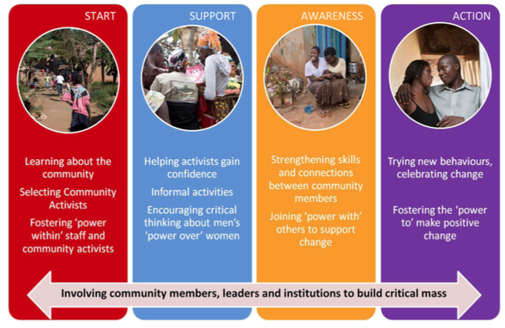
Figure 4: The SASA! approach: how it works¹
SASA! works with community activists, leaders, and professionals, on activity which includes community conversation, door-to-door discussions, training, and a multi-media campaign (materials and events). SASA! helps people to explore less rigid gender roles, but does not use instructional messaging, instead enabling a process of consciousness raising.⁴ Over four years this approach was used by SASA! to involve over 400 community activists who led more than 11,000 activities.⁷
SASA! is one of the few CM initiatives worldwide to complete comprehensive research and evaluation. This research supports the effectiveness of the intervention to prevent violence against women. See the section Assessing Change for more information.
Resources: Raising Voices website and SASA! toolkit and SASA! video

Challenges
The section below outlines important aspects of CM and common challenges.

Leadership
Community mobilisation initiatives need formal and informal community leaders to lend their mandate and support to projects in order to encourage participation from the wider community and activate local resources. However, it can be problematic when leaders either dominate (not allowing space for local ownership and new leaders to emerge) or withdraw (not providing a sense of importance and urgency for the work).
Some suggest that CM actually requires more leadership, but a different kind, specifically leadership that is enabling and facilitating rather than controlling. Michau¹⁶ refers to this as “power with” (rather than hierarchical leadership that is “power over”). For the family violence sector working with CM, the challenge can be about letting go and being able to move beyond ownership of the issues, to allow new people in the community to step up.
The perspectives and actions of leaders within communities influence the process. Becoming a leader can mean it is necessary to change oneself before trying to make change in a community. When taking a public stand against violence, having integrity in the eyes of the community is critical, and goes beyond not using violence. Leaders must have a good understanding of violence and abuse, and be able to model healthy ways of relating.
People associated with a family violence project, including leaders, need to be safe, trusted people who are violence-free. Leaders, champions, spokespeople and organisers may need to complete a Police check, give permission for their family and friends to be consulted, or sign a pledge that sets out expected behaviour and their agreement to be non-violent. CM leaders and champions may have histories of violence or other crime, and this can be a strength when engaging with community members. However it is important that these leaders are honest, can openly take responsibility for their behaviour, and can demonstrate they are on a journey of change.
It is essential for people coordinating CM initiatives to establish strong and trusting relationships with any community members who take a leadership role. This enables leaders to disclose past or current violence, and for coordinators to directly raise any concerns. A process for dealing with violence or inappropriate behaviour can include hearing from the victim(s), a family or whānau meeting, requiring the person to step down from a role, making a public statement, and/or agreeing to get professional support.

Time frame
Community mobilisation requires long-term commitment to develop understanding of how different communities work, and to initiate and sustain positive changes. This time frame can be challenging for all involved including organisers, leaders, action-takers, funders, and community members. Without population-based monitoring, it can be difficult to know if CM initiatives are effective at reducing violence as they will not usually lead to decreased rates of reported family violence. In fact, it is likely that reported rates will go up, due to increased reporting and disclosure of family violence. In light of this, short term and intermediate goals can be a useful way to for communities to outline a pathway for change, with small changes that can be built on over time.

Funding
Community mobilisation is difficult to start and sustain in a funding environment characterised by short term funding and a three-year political cycle. There is little funding available for family violence work that is not for services. The few New Zealand CM projects that have been funded have only secured time-limited support, which restricts the outcomes that can be achieved. For CM initiatives to have a chance of success, long-term funding of at least five to ten years, with clear contractual outcomes that allow for flexibility, learning and change around how these outcomes are achieved is needed.
Collaborative CM initiatives can involve many partners. It can be challenging to decide where funding is held, and where staff are located, in order to ensure that there is not ‘capture’ by one organisation which may benefit some more than others. Addressing the competitive funding environment within the sector is also essential. Currently there can be competition between those seeking to develop prevention initiatives and those providing direct services. In some cases, prevention initiatives have been closed down because funding has been redirected to service provision.⁵⁶ The competitive funding model can undermine collaboration and information sharing between organisations. While there have been attempts to address this by changing the ways that contracts for service provision are administered, these efforts have not been sustained. For example, the government’s Family Violence Funding Circuit Breaker Initiative in the 2000s was a collaborative contracting initiative that aimed to provide greater co-ordination and alignment of government funding, and reduce compliance costs for community organisations. However this initiative is not ongoing.⁵⁷

Services
While the aim of CM is preventing family violence, any project that encourages community conversations is likely to result in more people seeking help for themselves and others. This means it is important to locate, promote, and partner with services within the community, helping to ensure they have the capacity to respond to increased demand. It may also be necessary to advocate for new services where there are gaps. Mobilising community members may mean that they become aware of local services, and want to have more say in how services can better meet local needs.

Skills
The skills required for primary prevention, coalition building, community development, research and facilitation can be different from those usually found in the family violence sector, and a workforce development strategy needs to include building these skills. The CM workforce needs to competently deal with new challenges such as:
- Tolerating a level of uncertainty and messiness in learning what works
- Juggling many diverse activities at once
- Being open to learning from failure
- Listening to the community, rather than telling
- Ensuring safety for people affected by violence, while working in new ways.
Skills to deal with personal challenges may also be needed. Being part of CM work often involves a personal journey of self-awareness and reflection such as understanding the impact of past abuse, and constructively dealing with conflict. It can be very challenging, emotionally draining work, and involves wrestling with ethical dilemmas such as managing community partners who support the initiative but do not model the values. CM practitioners may need to develop a diverse support network including peer support and supervision.

Coordination support
Successful CM initiatives require intentional, focussed and skilled coordination support. Important skills of coordinators include community planning, facilitation, research, monitoring, training, relationship building, and communication.⁵⁹ However, it can be difficult for local communities to obtain funding and staff to undertake these key functions.
CM requires that national organisations and funders do not ‘step back’ to ‘let communities get on with it’, but rather invest in structural support that enables local ownership. A New Zealand review of collaboration and coordination found that there needs to be a strong national mandate and leadership for agencies to work collaboratively.³²
In order to improve the effectiveness of local initiatives, New Zealand experts have recommended sustained investment and support for current family violence networks. These networks and their coordinators are the main groups driving local CM initiatives. According to the expert group there is a need for dual coordination roles with distinct functions – one to focus on primary prevention and another to coordinate local responses to family violence.⁶⁰ They also called for the establishment of a national family violence network coordinator role with supporting secretariat, to oversee the integration of government and community provision of primary prevention programmes. Local networks themselves have advocated for a national coordinator, arguing for a role to inspire and support local efforts and develop a nationally consistent approach. A New Zealand review of collaboration and coordination noted the need for national leadership on family violence that included policy and financial support for local family violence network coordinators, claiming that networks with dedicated coordinators are more assured of maintaining momentum and resolving local issues than those without.³²
In New Zealand there are over 45 family violence networks, many of which currently have some funding to provide coordination support through the Family Violence Response Coordination Fund from Ministry of Social Development. However, the funding is short term, is not solely for prevention work and has been uncertain from year to year.

Assessing change
Community mobilisation requires long-term commitment and investment, however there are examples that demonstrate substantial reductions in violence from adopting this approach over relatively short timeframes. CM is difficult to measure and it can be difficult to attribute change to a specific initiative. Evaluation is sometimes used to determine the degree to which community mobilisation may be occurring, but often the impact of discrete activities is assessed, rather than measurement of the combined impact of multiple efforts to mobilise a community. Assessing behaviour change at a community level is complex, and to make it worthwhile to undertake an outcome evaluation, it is important that the initiative is well embedded within the community, and that there is sufficient resourcing and commitment for both the CM initiative and the evaluation activities.

SASA!
The SASA! study carried out comprehensive assessment, involving quantitative and qualitative research including a randomised control trial in eight communities (four intervention, four control),⁷ and 40 in-depth interviews (20 women, 20 men).¹
The pair-matched cluster randomised control trial established a baseline in 2007/2008 and completed a follow up assessment in 2012. A comprehensive survey was used to assess: the household; attitudes and social norms; health and relationships; sexual health and experiences; violence and community response; prevention and response in the community; and, exposure to SASA!
Results showed that in the intervention group there was reduced social acceptance of gender inequality and intimate partner violence (IPV), including lower social acceptance of violence against women, and greater acceptance that women can refuse sex. There was a decrease in women’s experience of IPV, and lower past year experience of physical and sexual violence among women (50% lower than control communities). Findings showed women in the intervention group were three times more likely to receive a helpful response when seeking help for IPV. Also, men reported reduced concurrent sexual partners (27% in intervention communities, 45% in control communities).
The in-depth interviews showed that SASA! influenced dynamics of relationships and broader community norms.¹ At the relationship level SASA! was found to be helping partners to: understand the benefits of mutually supportive gender roles; improve communication; increase levels of joint decision making; and, to highlight non-violent ways to deal with anger or disagreement. At the community level SASA! has helped to: foster a climate of non-tolerance for violence; reduce the acceptance of violence against women; and, increase people’s skills, willingness, and sense of responsibility to prevent violence. The study also found that SASA! had challenged previous norms that women should not talk about the violence they were experiencing.

Other ways to assess change
For many community-based initiatives, the comprehensive level of research employed by SASA! is not feasible, however there are more realistic ways to start to assess change.
For new and small scale projects, developmental evaluation may be a useful place to start. There may also be value in using less resource intensive tools to inform planning and to assess change. Two examples of this are the Community Readiness and Theory of Change models. These two tools are summarised here as they show some promise for use alongside CM initiatives.⁶⁴

The Community Readiness Model
The Community Readiness Model (CRM) assesses a community’s efforts, leadership, culture and resources to determine the level of readiness to address a community issue.⁶⁵ Readiness is defined as the degree to which a community is prepared to take action on an issue.⁶⁵
The CRM uses semi-structured key informant interviews to assess six dimensions of community readiness (community efforts; community knowledge of efforts; leadership; community climate; community knowledge about the issue; resources related to the issue).⁴⁴ Interviews are scored using an anchored rating scale, and these scores translate to a stage of community readiness. The CRM defines nine stages of community readiness, from No awareness through to High level of community ownership.
The CRM can be used to measure community change by establishing a baseline and completing follow up assessments over time to track if there is movement from one level of readiness to another. Baseline results can also be used to develop a CM initiative that fits the level of readiness present in a community. The HEART Movement used this tool in their development.
Resources: CRM Handbook

Theory of Change model
“Programming should be informed by theories of change that address the complexity of individual and social change processes. Theory-informed programming supports the development of programme components that are complementary and mutually reinforcing rather than stand-alone interventions” – Lori Michau⁴
Theory of Change provides a comprehensive approach to planning. The model articulates the underlying assumptions of an initiative, capturing the workings by linking outcomes and activities to explain how and why change is expected to come about.⁶⁸ Specific indicators are developed for each outcome and these indicators must be adequately met before work progresses at the next stage.⁶⁹ This process enables articulation of a “pathway of change” for the initiative, representing the relationship between planned actions and outcomes, and how the outcomes are related to each other over the lifespan of the initiative.⁶⁸

The HEART Movement
HEART used Theory of Change⁶⁸ to develop a long-term plan. The goal of HEART is “Glen Innes and Pt England homes actively grow loving, safe and supportive relationships.” Considering that this is a big shift to create within a community, the working group suggested a 20-year horizon for the work. Many initiatives agree an aspirational long-term goal, but do not map the steps towards achieving this goal, and momentum wanes as people feel overwhelmed by the enormity of the task.
Below is the proposed pathway of change for the HEART Movement. The map suggests, for example, that to have effective active leadership in place in the community may require a process of community engagement, increased personal relevance, and intolerance of unhealthy relationships. It is hoped that this may lead to increased ownership of the issue within the community.

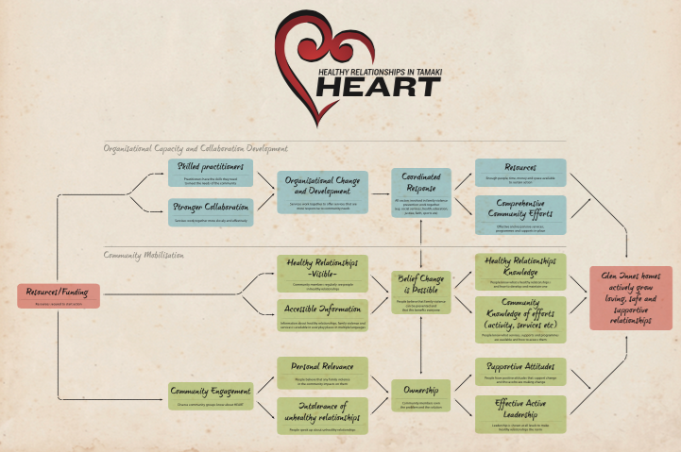
Figure 4: The HEART Movement Theory of Change
Resources:
A guide to developing a Theory of Change is available online
The toolkits below also outline other methods that are accessible and can be low cost such as Most Significant Change, Photovoice, and Developmental Evaluation.
The Social Change Toolkit
For social and community change practitioners, includes a section on research and evaluation
Tamarack – Measuring Community Change
A review of a wide range of community change initiatives and the measurement tools and techniques used

The way ahead
Community mobilisation can be transformative. The power of people taking action and showing leadership because they care is huge and can be harnessed.
Supporting this work to develop requires thinking in new ways from all involved, from practitioners and community members to funders and policy makers. It also requires some different, sustained, adequate investment in coordination roles, workforce development, and new leadership skills.
Community mobilisation initiatives that are underway around the country are often facilitated by local family violence networks. There is an opportunity to build on this momentum by investing in a national and local infrastructure. This investment in communities could reduce the level of funding required in the long-term.
The ability to assess CM initiatives is important in order to provide evidence of what actions work to create change. Documenting initiatives and telling stories of success and change can be a useful starting point for sharing what is being learnt in communities. In the longer term, more research and evaluation is needed to determine the effectiveness of these initiatives.
Internationally, there is evidence that CM efforts can lead to substantial reductions in violence over relatively short periods of time. In New Zealand there is currently strong community support to prevent family violence in a way that is consistent with community mobilisation, and there are initiatives underway in a number of communities. There is significant potential for social change if community mobilisation is prioritised and resourced.

References

Violence and abuse against any person whom that person is, or has been, in a domestic relationship with. This can include sibling against sibling, child against adult, adult against child and violence by an intimate partner against the other partner.

